PART 1: COACHING DEFINITION AND THEORY

Objectives:

Participants will read, analyze in writing and apply theoretical bases, and specific behaviors that impact the effect of instructional coaching.

1.1 Participants will explain to a partner a one sentence summary of coaching and feedback framework for transformation.

1.2 Participants will explain in writing their definition of coaching.

1.3 Participants will explain in writing the implication of coaching on teaching, learning and professional development.

1.4 Participants will explain in writing the relationship of Situational Leadership Theory and instructional coaching.

1.5 Participants will explain to a partner how the 80-15-5 Formula relates to their school and/or district.

1.6 Participants will compare and contrast the types of coaching through a metaphorical non-linguistic representation that portrays the relationships among the models.

1.7 Participants will explain to a partner the relationship of Adult Learning Theory and Situational Leadership.

1.8 Participants will explain in writing how Adult Learning theory impacts instructional coaching.

1.9 Participants will explain in writing how Conceptual Systems Theory can be used when coaching adult learners.

1.10 Participants will explain in writing the relationships among Adult Learning Theory, Conceptual Systems Theory, Situational Leadership and the Will/Skill Matrix and how they can be applied within their school and/or district.

1.11 Participants will write and discuss the importance of building trust when coaching and determine a personal goal to build trust within their school and/or district.

1.12 Participants will explain the importance of building rapport when coaching and write actions to building rapport within their school and/or district.

1.13 Participants will explain to their partner the importance of listening as an instructional coach and practice identified listening skills.

1.14 Participants will explain to their partner the impact of non-verbal communication has on instructional coaching.

Introduction to Coaching:

This model of coaching for transformation is based upon the work of several historic and current day researchers and practitioners. The heart of the model emphasizes the need of coaches to adapt their coaching style or preference to the needs of the person or program being coached. This coaching framework is a hybrid model that focuses on individualized needs of educators and programs. These strategies are designed to be deployed with individuals working to improve others’ instruction, directors working to increase program implementation, administrators leading whole school reform, coaches coaching classroom management or other strategies – a wide variety of coaching opportunities. Based on the extensive experiences of CSAP staff members coaching thousands of individuals and programs annually, the subsequent model delineates the best practices formulated by numerous coaching programs, authors, and researchers. Every effort has been taken to give credit to the program or author referenced throughout this module.

Primary Theories and Models

Influencing change in an individual’s attitudes, beliefs, and behaviors is the crux of transformational leadership (Bass & Riggio, 2006; Northouse, 2010) -- a powerful theory and style of leadership for leaders to aspire to. At the same time, few school leaders and coaches actually take the time to assess changes in beliefs and attitudes explicitly, instead measuring teachers and program changes through changes in behaviors. While this model does not advocate working on behavioral changes solely, it does often rely on using outward behavior changes to indicate movement in internal attitudes or beliefs. Rather than solely relying on transformational leadership, this coaching model is primarily aligned with situational leadership theory (Hersey & Blanchard, 1977; Northouse, 2010). The fundamental underpinning of situational leadership theory is there is no single best style of leadership. Effective leadership is task-relevant, and the most successful leaders are those that adapt their leadership style to the ability of the individual and the task at hand. Blanchard and Hersey’s theory is supported by a strong empirical base that encompasses, in their terms, both telling – or coaching which they characterize as close management – and delegating or lose management. In educational coaching vernacular this same premise is often referred to as reflective or cognitive coaching and directive or instructional coaching (Costa & Garmston, 2002; Bloom, Castagna, Moir, & Warren, 2005). The coaching model in this module embraces all those aspects or styles of coaching. Madeline Hunter embraced this style of supervising in the late 1970s (Hunter, 1980). More currently, two books promote the idea of using a variety of coaching models and strongly influenced this module on coaching are The Art of Coaching (Aguilar, 2013), Blended Coaching (Bloom, Castagna, Moir, & Warren, 2005) and Comprehensive Mentoring Programs for New Teachers (Villani, 2009).

Secondary Models and Theories

Villfredo Pareto, an Italian sociologist from the late 1800s noted that 80% of Italy's land was owned by 20% of the population (Pareto, 1895). He developed the infamous Pareto Principle stating that in most situations roughly 80% of effects come from only 20% of the causes. The Pareto Principle has been applied to almost every human enterprise, from software development to investing. We apply this theory to the work of coaching teachers as it informs advice on how much time should be spent coaching, where the coaching should take place, and how frequently the coaching school occur. Two more current references developing Pareto Principle into practice include Gladwell’s The Tipping Point (2002) and Moran’s Differentiated Literacy Coaching (2007). Look for ideas from these authors to surface when this module addresses formats for coaching and differentiating for teachers or anything else that references time, structure, or placement of coaching. Finally, much of the work in this module is influence by the work of Lev Vygotsky (1978) and his theory of the Zone of Proximal Development. This theory addresses the nature of experiences and social contexts and their impacts on learning. This coaching model promotes experimenting with behaviors and ideas in order to produce results – changing experiences or contexts -- oftentimes prior or parallel to changing beliefs or attitudes about an idea, program, or practice.

References

Aguilar, E. (2013). The art of coaching: Effective strategies for school transformation. San Francisco, CA: Jossey-Bass.

Bass, B. M., & Riggio, R. E. (2006). Transformational Leadership (2nd ed.). Mahwah, NJ: Lawrence Erlbaum Associates.

Bloom, G., Castagna, C., Moir, E., & Warren, B. (2005). Blended coaching: Skills and strategies to support principal development. Thousand Oaks, CA: Corwin.

Costa, A. & Garmston, R. (2002). (2nd ed.) Cognitive coaching: A foundation for renaissance schools. Norwood, MA: Christopher-Gordon.

Gladwell, M. (2002). The tipping point: How little things can make a big difference. Boston, MA: First Back Bay.

Hersey, P., & Blanchard, K. (1977). Management of organizational behavior: Utilizing human resources (3rd ed.). Englewood Cliffs, NJ: Prentice Hall.

Hunter, M. (1980). Six types of supervisory conferences. Educational Leadership, 37(5), 408-412.

Moran, M. C. (2007). Differentiated literacy coaching: Scaffolding for student and teacher success. Arlington, VA: ASCD.

Northouse, P. (2010). Leadership: Theory and practice (5th ed.). Thousand Oaks, CA: Sage Publications.

Pareto, V. (1895). La legge della domanda [The law of supply]. Giornale degli economisti [Economists Journal], 10, 59-68. Geneva: Droz.

Villani, S. (2009). Comprehensive Mentoring Programs for New Teachers: Models of Induction and Support. (2nd ed.). San Francisco, CA: WestEd.

Vygotskiĭ, L. L. S. (1978). Mind in society: The development of higher psychological processes. Edited by Cole, M., John-Steiner, V., Scribner, S., & Souberman, E. Cambridge, MA: Harvard University Press.

Activity: Read the following excerpt from Robyn Jackson’s book, “Never Underestimate Your Teachers: Instructional Leadership for Excellence in Every Classroom.” (2013)

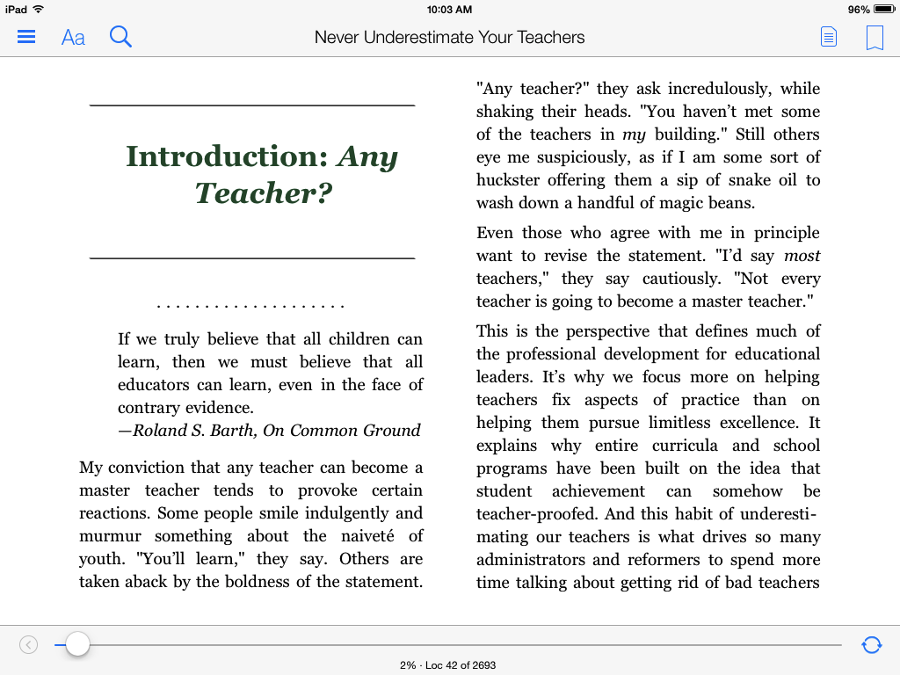

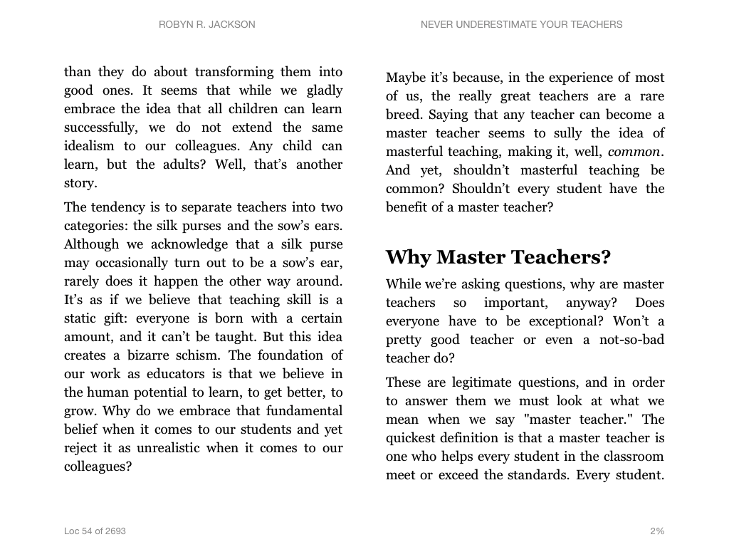
**(STOP READING AT “WHY MASTER TEACHERS?”

Quick Write: After reading the excerpt and the quote below, respond to the following question: Do you believe that all adults are capable of learning at a high level? Why or why not? Record your response in the space below.

“If we truly believe that all children can learn, then we must believe that all educators can learn, even in the face of contrary evidence.”
Roland S. Barth, On Common Ground

1.2 What Coaching is and What Coaching is Not?

What Is Coaching?

Coaching is creating change in a teacher’s attitudes, beliefs, and actions. Change, after all, is only another word for growth, another synonym for learning. We can all do it, and enjoy it, if we want to. All we have to do is change our attitudes, our habits, and the ways of some of our institutions. -- Charles Handy

Professional dialogue is conversation in which people think together in relationship with one another. It is a conversation that focuses on purpose and significance, and evokes understanding which makes a difference to student and adult learning. It is a conversation about what is worthwhile. It is a conversation that is purposefully planned by the coach who uses inquiry questions to elicit ideas, opinions, and problem-solving for the purpose of enhancing teacher and student performance. -- Tabor, 2001

Coaching is the new buzz word for professional development in education and has become a popular model for professional development in schools (Poglinco & Bach, 2004). Wood and McQuarrie (1999) describe effective coaching as one of the most promising new approaches to professional development in education; however, coaching is not a new concept. Students and adults have been coached for years. Coaching is a conversation in which the coach provides the teacher with specific feedback on his or her performance in order to change or improve the performance and/or maintain the effectiveness of the performance. According to Costa and Garmston (2002)…”Skillful cognitive coaches apply specific strategies to enhance another person’s perceptions, decisions, and intellectual functions. Changing these inner thought processes is prerequisite to improving overt behaviors that, in turn, enhance student learning.”

In Hargrove’s book (1995), Mastery Coaching Extraordinary Results by Impacting People and the Way They Think and Work Together, he describes coaching as following:

A coach is someone who (1) sees what others may not see through the high quality of his or her attention or listening. (2) is in the position to step back (or invite participants to step back) from the situation so that they have enough distance from it to get some perspective, (3) helps people see the difference between their intentions and their thinking and/or actions, and (4) helps people cut through patterns of illusion and self-deception caused by defensive thinking and behavior.

Masterful coaches inspire people by helping them recognize the previously unseen possibilities that lay embedded in their existing circumstances.

Feedback is essential for learning at the individual, group, or organizational level. It is feedback that can help people see the discrepancy between what they think they are doing and what they are actually doing. It is feedback that can interrupt the defensive reasoning or routines that happen with individuals and groups. It is feedback that allows people to recognize and eliminate error and thus allows learning to occur. It can show people where new skills and capabilities need to be developed and lead to insights into ways to improve work processes.

In education, coaching sometimes is viewed as a new concept, because the only feedback teachers receive on their ability to teach comes in the form of an evaluation rather than as a means to learn how to improve the quality of classroom instruction. Hasbrook and Denton (2005) point out that coaching in education is essential because it is an effective and efficient way to strengthen classroom instruction and provide teachers with the necessary knowledge to improve the quality of instruction. Flaherty (1999) says coaching is a process that allows for teachers to change, become more competent, and to increase excellence in instruction. In addition, the research of Joyce et al. (1989) indicates when schools incorporate coaching as a major part of their professional development program, student achievement increases.

The goals of coaching in education are to help teachers learn how to provide high quality instruction and increase student learning and achievement. Speck (1996) states, “[Adults] need to receive feedback on how they are doing and the results of their efforts. Opportunities must be built into professional development activities that allow the learner to practice the learning and receive structured, helpful feedback.” One of the best ways to provide specific feedback to teachers is through a verbal interchange facilitated by a coach or administrator. When done effectively, teachers learn how to change or improve their ability to teach and/or maintain the effectiveness of their instruction and when teaching is effective, there is more student learning and achievement.

Activity: Triad read “What Coaching Isn’t?” Use the boxes below as a note taking guide. Partner A reads aloud. Partner B highlight important details. Partner C writes questions for discussion. After reading, discuss the questions from partner C.

What Coaching Isn’t?
Adapted from Bloom (2005)

Coaching isn’t training. Coaching addresses the needs of the individual. Coaching can and often does support training activities; however, training many times is top down. Coaching by contrast is centered on context and designed to respond to the needs of the individual learner.

Coaching is not mentoring. The terms “coach” and “mentor” are sometimes used interchangeably; however for our purposes, we define mentor as an organizational insider who is a senior expert and supports a novice. Mentors show newcomers the ropes and share procedures such as where to stand for duty at recess, how the lunch line is organized, and the dates for progress and report cards. A coach, on the other hand, provides continuing support and nurtures professional growth through a process that unfolds over time. Coaching is a professional practice; mentoring is typically voluntary and informal.

Coaching is not therapy. Coaching focuses on the accomplishment of professional goals rather than on an individual’s psychological function. Therapy involves understanding an individual’s past; coaching helps the individual change an organization’s future. Coaching occurs within the boundaries of normal professional issues. It is important that coaches be aware of these boundaries.

Coaching is not training. | Coaching is not mentoring.
Coaching is not therapy. | Questions

Activity: Explain your definition of coaching in the space below.

1.3 What can Coaching do for a School? Why is Coaching Effective?

Activity: As you read the excerpt below from Aguilar (2013), annotate your reading for key ideas and findings that impact coaching, professional development and classroom implementation. (READING BEGINS AT “WHAT CAN COACHING DO FOR A SCHOOL?”)
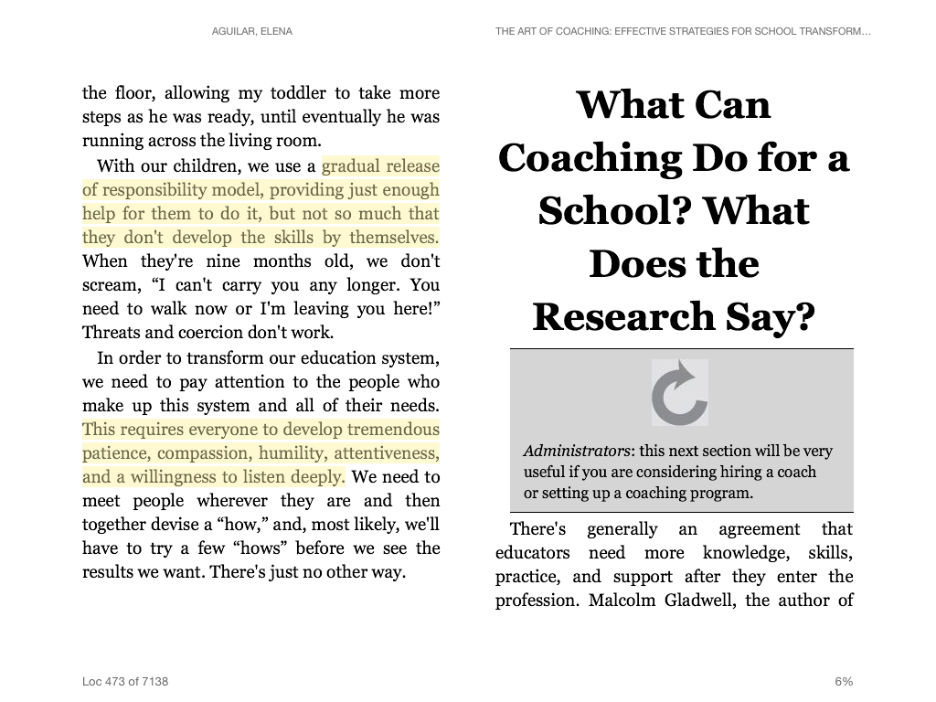

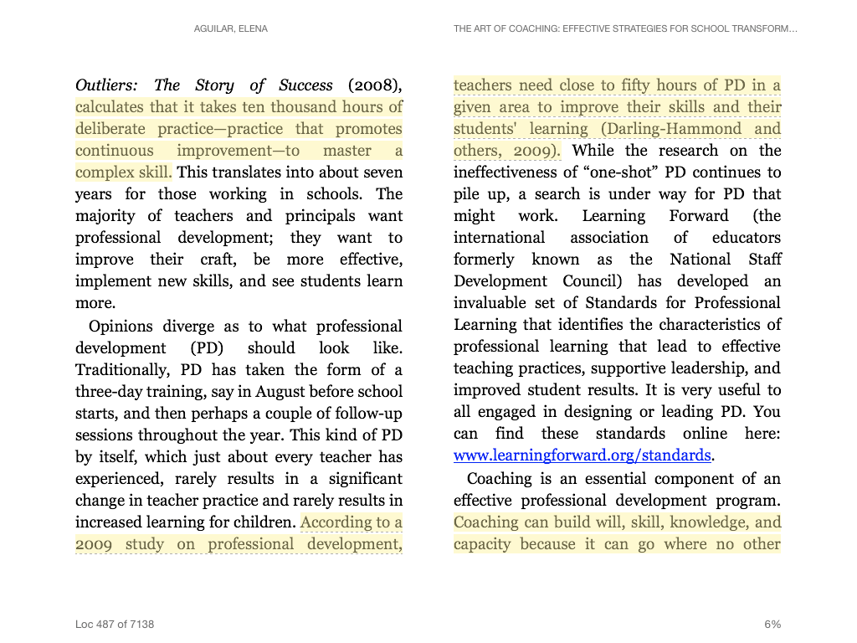

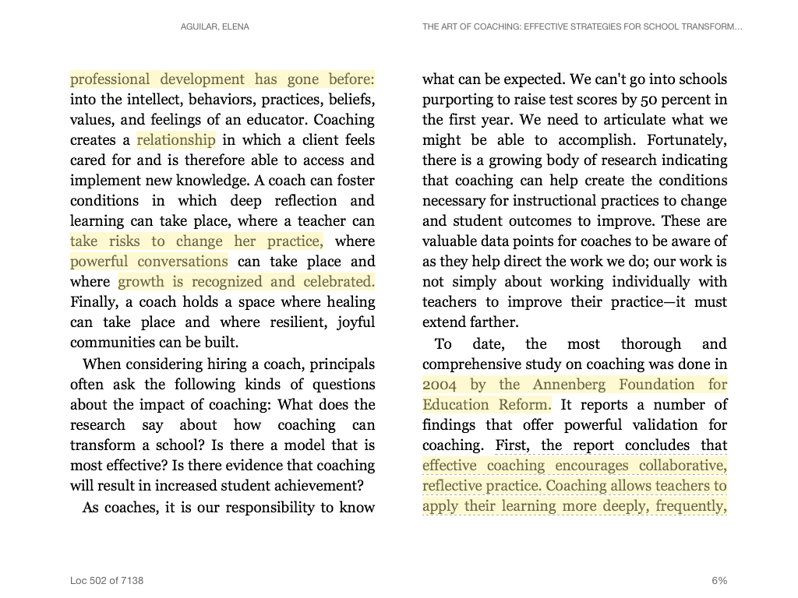
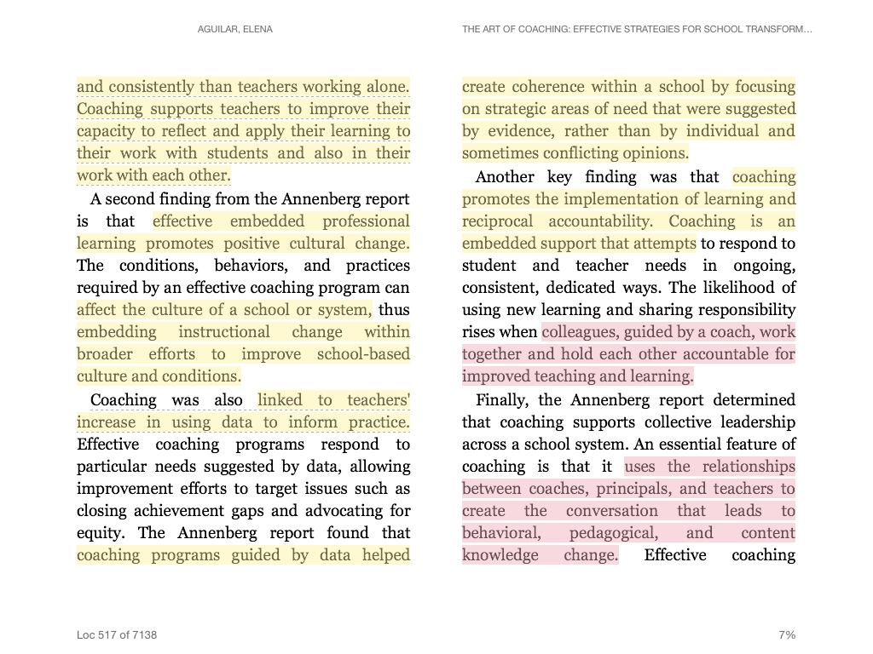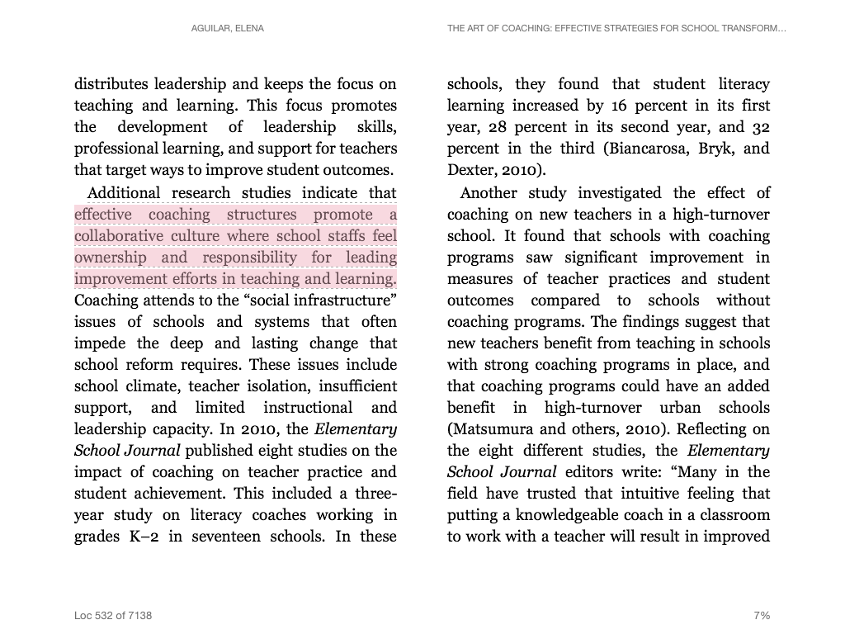
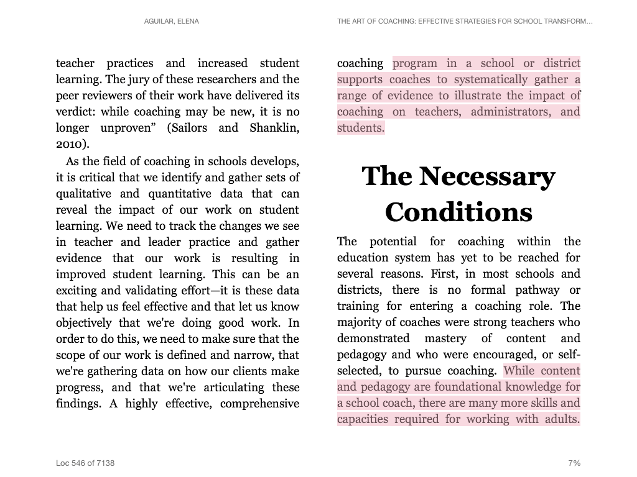
**(READING STOPS AT “THE NECESSARY CONDITIONS”)

Activity: Write a quick summary of the text you just read and how you can apply this information to your school setting. Record your response in the space below.

Activity: Read the text below highlighting research by Joyce and Showers (2002), as you read annotate for implications for improving teaching and learning.

Why Coaching Is Effective
Joyce and Showers (2002)

Many of the research states that teachers have more effect on student achievement than any other factor, including school management, resources etc. To improve achievement we must improve teaching, and only teachers can do this. So we must get teachers to experiment.
In their book Student Achievement through Staff Development, American researchers Bruce Joyce and Beverly Showers argue that professional development often assumes that once teachers learn and develop a skill, they will automatically use it in the classroom. Yet their research reveals that learned knowledge and skills rarely transfer to the classroom. They do, however, report a noticeable increase in transfer when coaching is added to a teacher’s training. They argue that professional development supported by coaching that allows for a transfer of skills into instructional settings is crucial for meaningful and lasting professional learning.
According to Joyce and Showers (2002), the degree of proficiency attained in knowledge, skill, and application is determined by the following training design. The strength of coaching rests on total cumulative effect of theory, demonstration, practice, and coaching. It takes an average of 23 practices to change a teacher behavior.

The first few attempts with a new method may fail, and the teacher may then be tempted to abandon further experiments – this is where the support provided by peer coaching is so vital. Teachers are very capable learners, but all learning requires time, practice and support, and the time for change has been greatly underestimated.

Below is a table that outlines Joyce and Showers research:

Training Effectiveness
Training  Steps | Mastery | Skill  Acquisition | Classroom Application
Theory & Lecture | Medium  85% | Low  15% | Very Low  5-10%
+  Demonstration | Medium  85% | Low  18% | Very Low  5-10%
+  Practice | Medium  85% | Medium  80% | Low  10-15%
+  Coaching | High  90% | High  90% | High  80-90%

There is more to coaching than advice and guidance on the implementation of improved teaching strategies. However, a good coaching session is inspiring, it fosters a blame-free culture where initial failures are inevitable and seen as valuable learning experiences. It shows how to make ideas work in the challenging reality of the classroom. Teachers often leave coaching sessions with their determination to succeed redoubled.

Joyce and Showers’ (2002), review of the research, makes some other telling points. They insist that the goal of professional development should not be simply to get the teachers to adopt new methods and practices. Rather, it should aim to change the way the teachers think about teaching. The experience should model and appeal to fundamental principles of good teaching and learning. Once teachers think in a new way about teaching and learning, they will often find multiple ways to apply these principles.
Activity: Highlight 1-2 quotes that are the most impactful regarding improving teaching and learning. Write the quotes below and explain why you selected them. Be prepared to share with your partner.

Quote #1:

Why I selected this quote?

Quote #2:

Why I selected this quote?

1.4 Situational Leadership Theory and Coaching

Situational Leadership Theory
The situational leadership theory,is a leadership theory developed by Paul Hersey, professor and author of the book Situational Leader, and Ken Blanchard, leadership guru and author of The One Minute Manager, while working on the first edition of Management of Organizational Behavior (now in its 10th edition).^{[1]} The theory was first introduced as "Life Cycle Theory of Leadership".^{[2]} During the mid-1970s, "Life Cycle Theory of Leadership" was renamed "Situational Leadership theory".^{[3]}
In the late 1970s/early 1980s, the authors both developed their own models using the situational leadership theory; Hersey - Situational Leadership Model and Blanchard et al. Situational Leadership II Model.^{[4]}
The fundamental underpinning of the situational leadership theory is that there is no single "best" style of leadership. Effective leadership is task-relevant, and the most successful leaders are those that adapt their leadership style to the maturity ("the capacity to set high but attainable goals, willingness and ability to take responsibility for the task, and relevant education and/or experience of an individual or a group for the task") of the individual or group they are attempting to lead or influence. Effective leadership varies, not only with the person or group that is being influenced, but it also depends on the task, job or function that needs to be accomplished.^{[5]}
The Hersey-Blanchard Situational Leadership Model rests on two fundamental concepts; leadership style and the individual or group's maturity level.
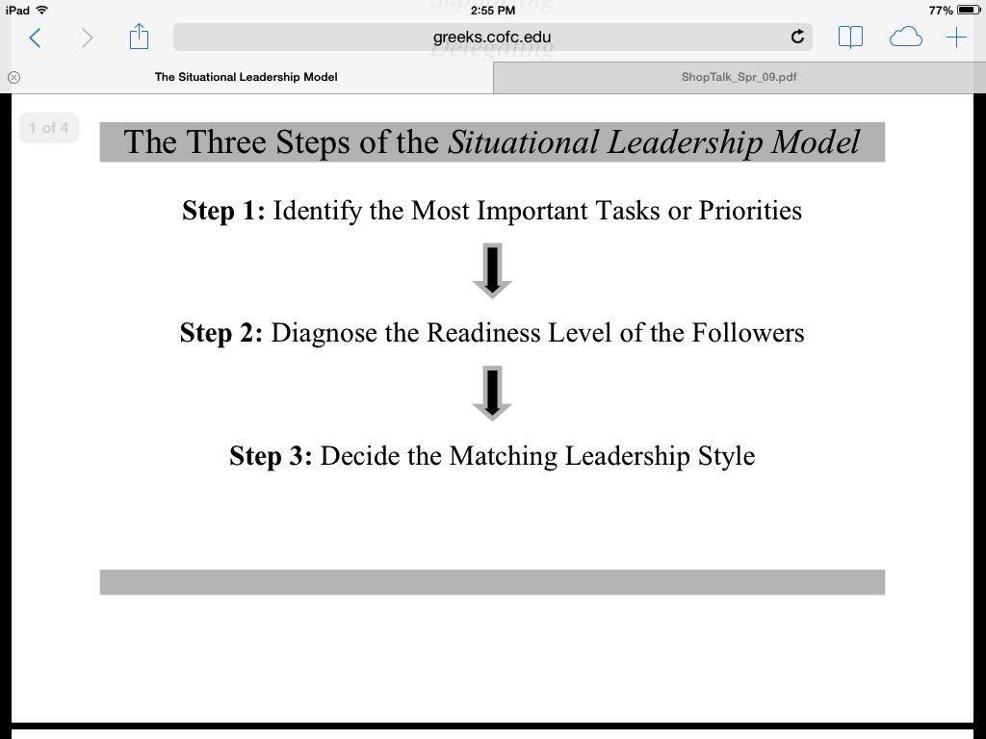

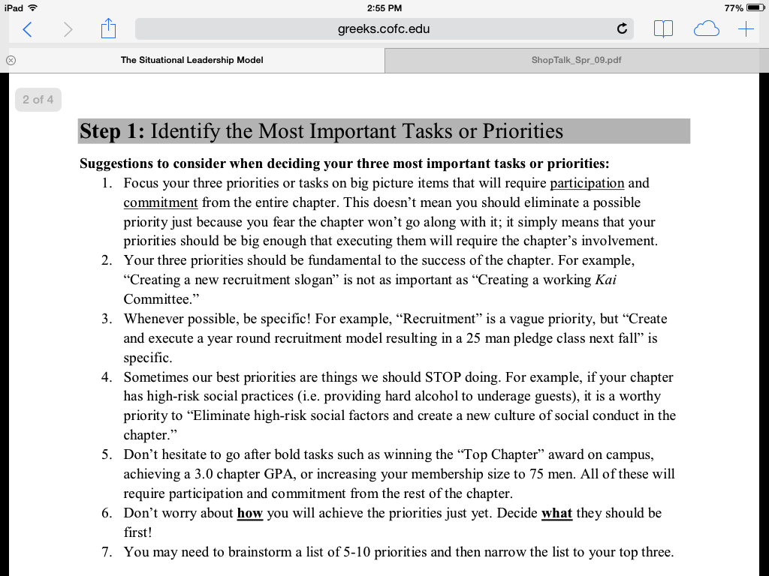

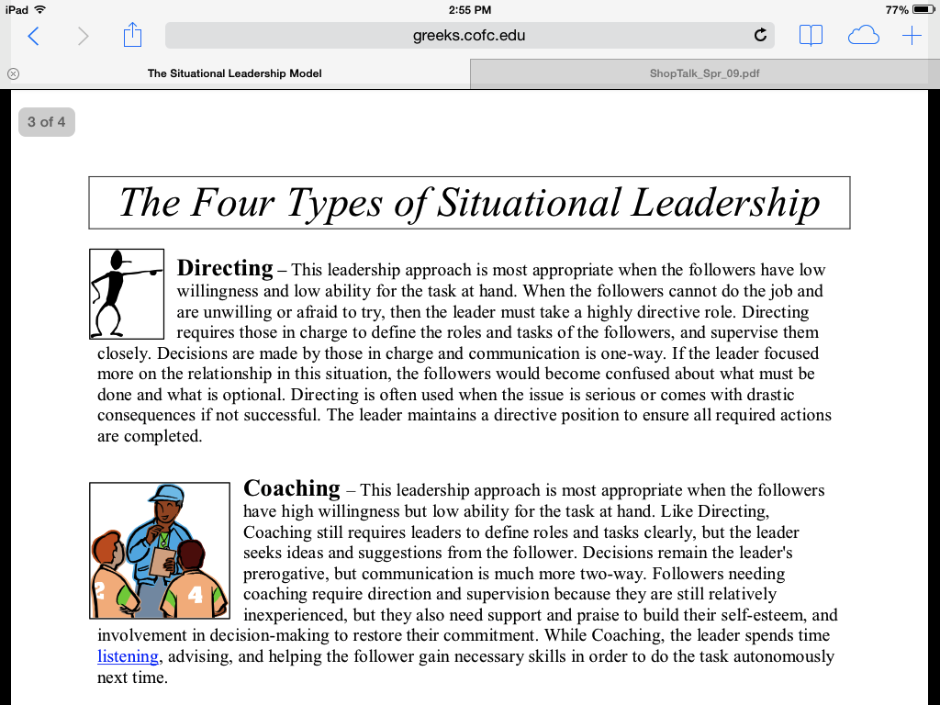

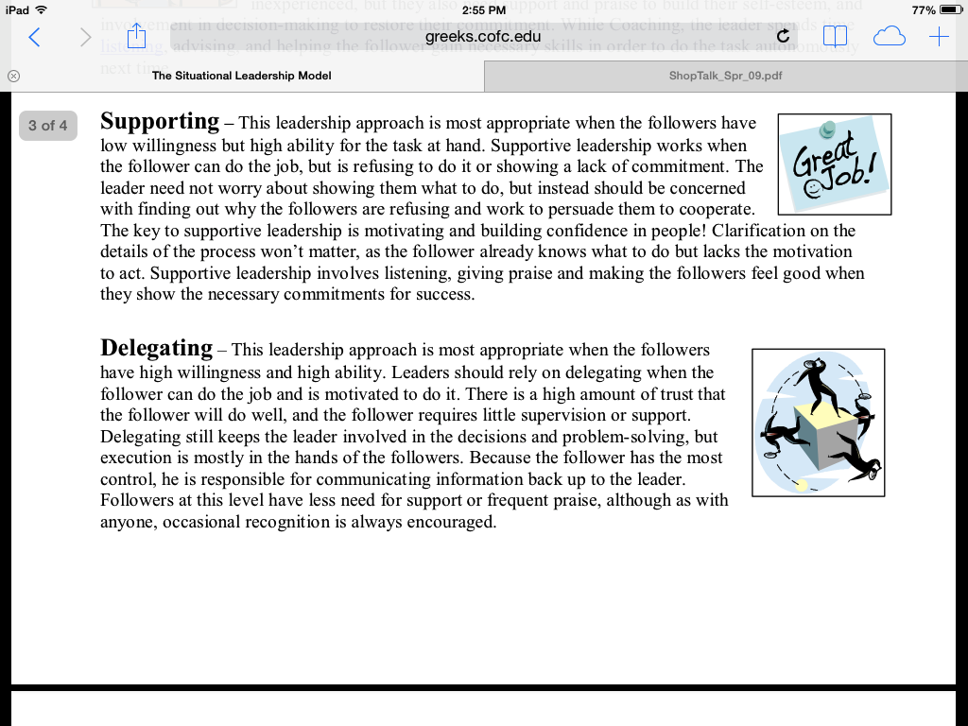

Situational Leadership Theory

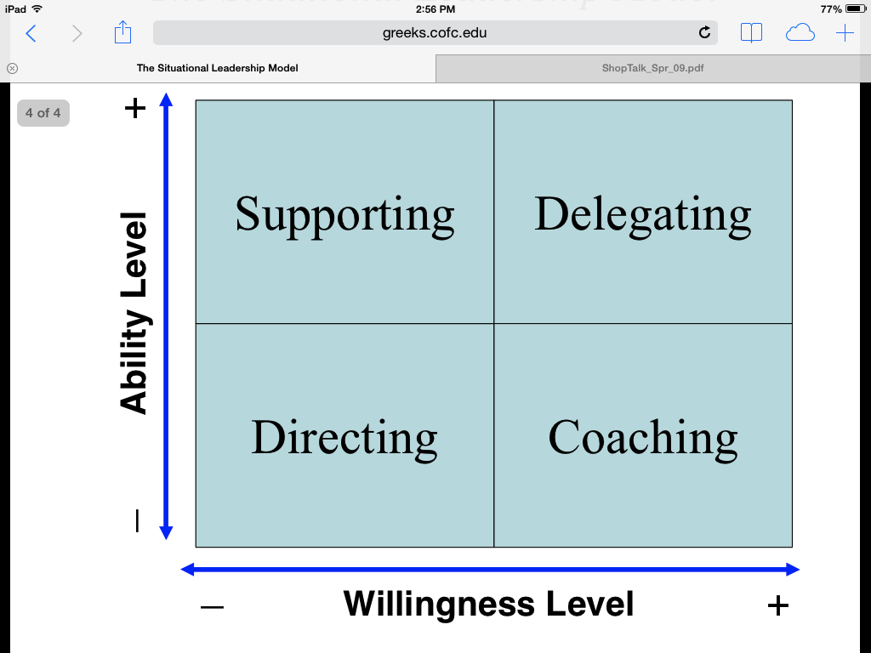

Activity: After reading and discussing Hersey and Blanchard’s “Situational Leadership Theory,” describe your thoughts on the relationship between this leadership theory and instructional coaching. Be prepared to share. Record your response in the space below.

1.5 80-15-5 Formula

80-15-5 Formula

The 80/20 Principle was first discovered by Pareto in 1897 when he determined that 80 percent of the wealth was enjoyed by 20 percent of the population. According to Koch (1998), “The 80/20 Principle states that there is an inbuilt imbalance between causes and results, inputs or outputs, and effort and reward” (p.21). This Principle is has also been studied by Curwin, Mendler, Mendler, (2008) and in Malcome Gladwell’s, book (2002) “The Tipping Point: How Little Things Can Make a Big Difference.” This could possibly mean that in schools, 80 percent of student growth comes from only 20 percent of the teachers. Let’s discuss how the 80-15-5 Formula works with coaching.

80-15-5 Formula for Teachers
Adapted from Curwin, Mendler, and Mendler (2008), Gladwell (2002)
80%
of teachers need
15%
of teachers need
5%
of teachers need

1.6 Coaching Models

Activity: As you read the excerpt below from Aguilar (2013), annotate your reading for key ideas, similarities and differences of the various coaching models described below.

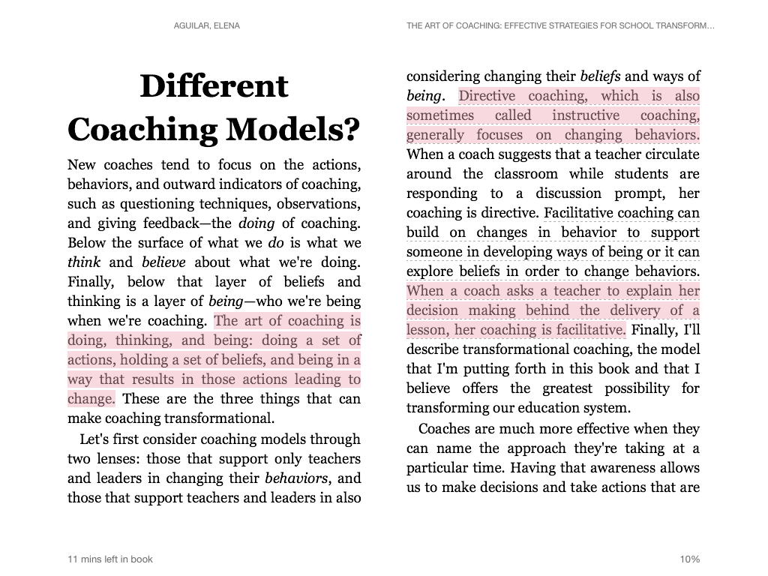

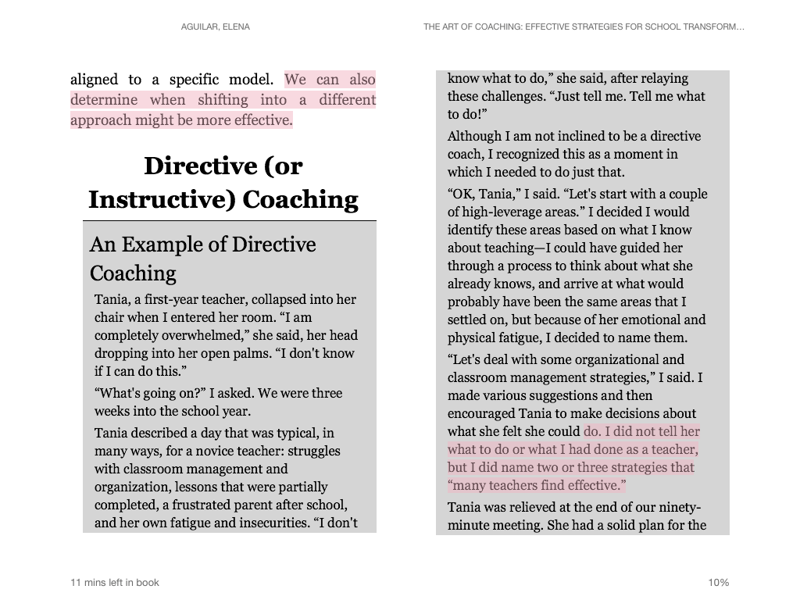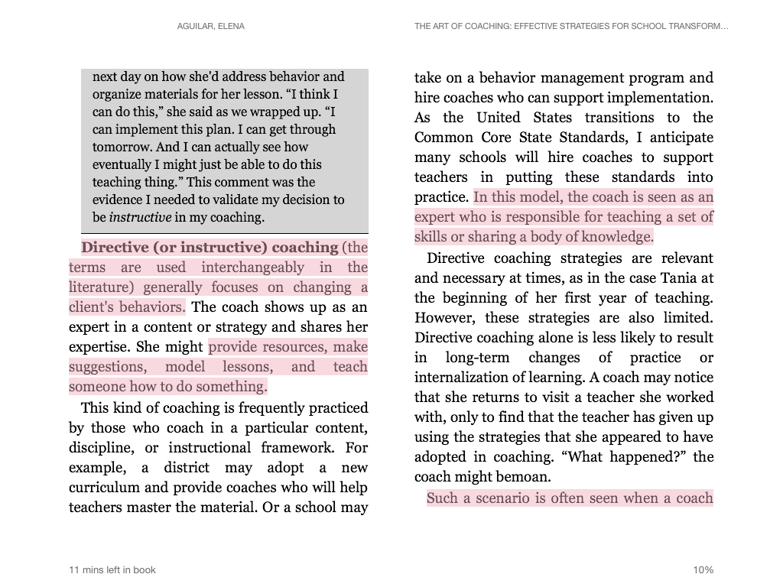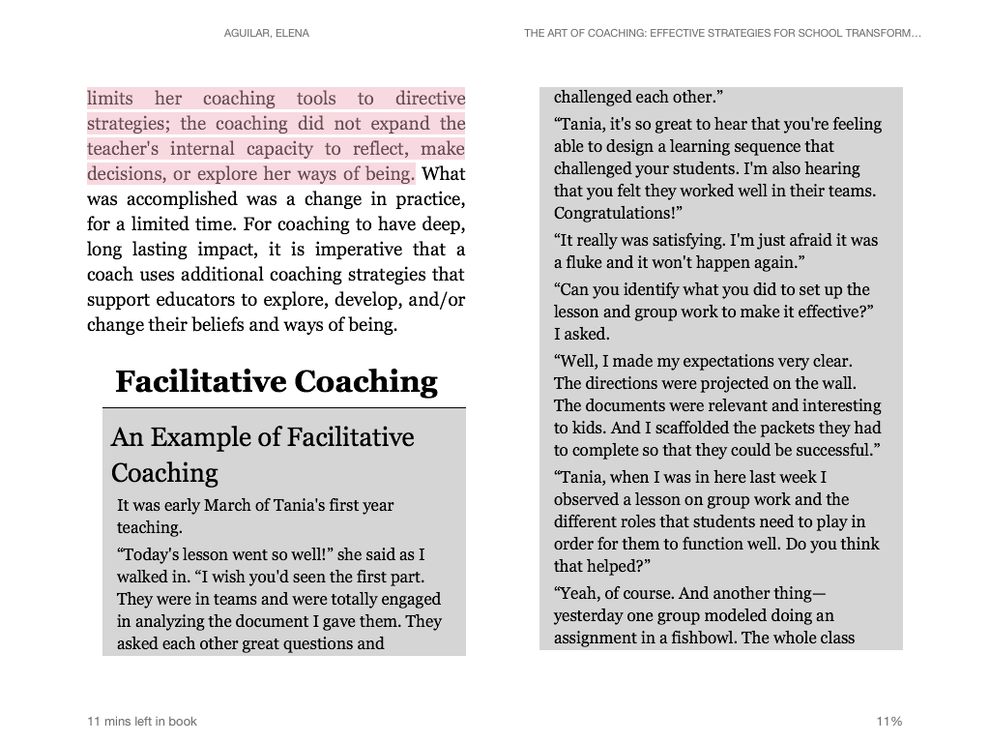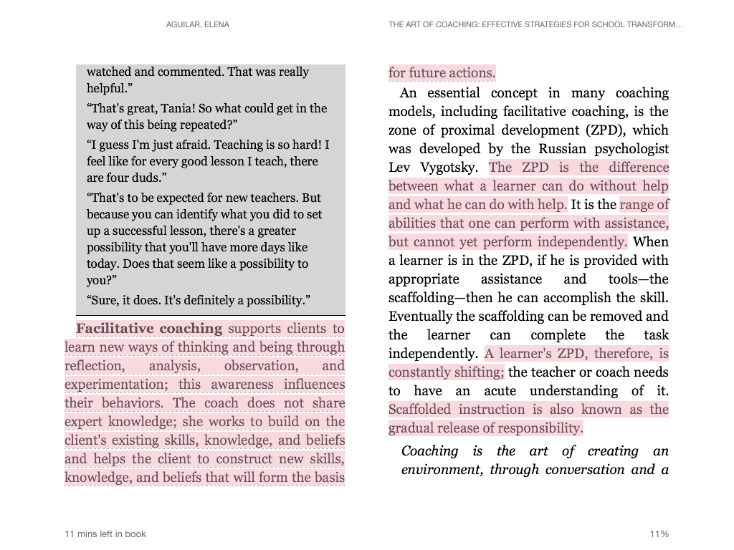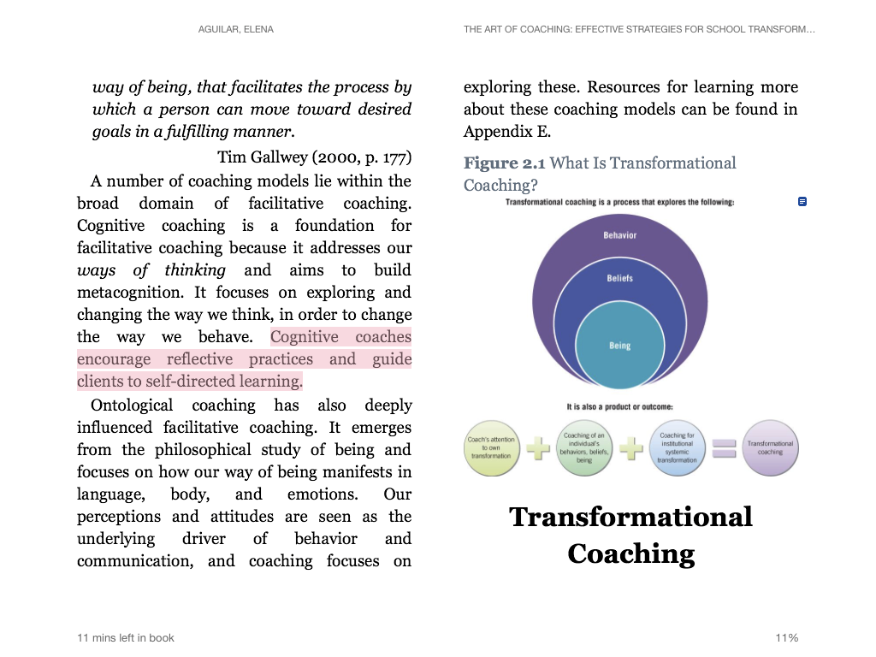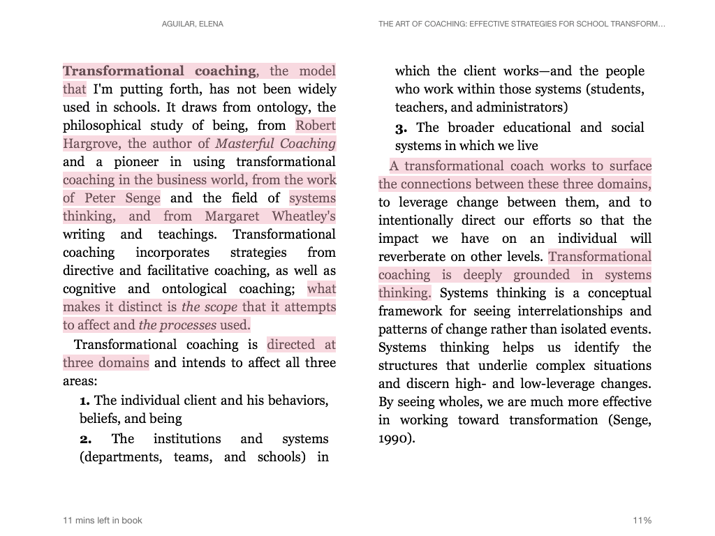
Activity: Using all the information presented, on a separate sheet of paper, with a partner create a non-linguistic representation of the similarities and differences of the three types of coaching. Be prepared to explain your thinking. After viewing additional representations, in the space provided below, write a summary of the types of coaching models.

1.7 Andragogy: Adult Learning Theory

Andragogy: Adult Learning Theory

Knowles, Holton, and Swanson (2011) in their book address the concept of andragogy -- which they defined as “the art and science of helping adults learn” -- into American adult education literature. They assert that adults require certain conditions to learn. Knowles, Holton, and Swanson (2011), contrasted andragogy with pedagogy (defined as the art and science of teaching children), which was the traditional teaching method for all learners, regardless of age, prior experience, or developmental level. In their work they further identified five primary assumptions about the characteristics of the adult learner, which are widely accepted and implemented by practitioners in this field. The five primary assumptions are, in general, adults:

- Tend to be self-directing
- Have a rich reservoir of experience
- Are goal-oriented
- Have a problem-centered orientation to learning
- Want practical, how-to information

Knowles in his later work conceded that four of andragogy’s five key assumptions apply equally to adults and children. One difference exists however, children have fewer experiences and pre-established beliefs than adults and thus have less to relate. One other difference to note is adults’ reasons for learning are very different than children. It is important to know and use the principles of andragogy when working with adults in a learning situation in order to facilitate adult learning and growth.

Activity: Quick Write

Why would coaches need to know about adult learning theory? Record your response in the space provided below.

Andragogy and Coaching
Adults have a problem centered orientation to learning
Adults generally desire practical, how-to info
Adults tend to be goal oriented
Adults have a rich reservoir of experience
Adults tend to be self directed
How to Address Andragogy – Adult Learning Theory -- While Coaching

1.9 Conceptual Systems Theory

Conceptual Systems Theory

Conceptual Systems Theory by Harvey, Hunt and Schroder (1961) is a framework that describes how people relate to their experiences. The four stages of the framework are characterized by differences in cognitive complexity or the degree of abstractness, the ability to differentiate and integrate new information, the ability to discriminate among conflicting situations, and interpersonal maturity.

How is Conceptual Systems Theory helpful to coaching? Applying this theory puts the coach in a stronger intellectual and emotional state for dealing with challenging behaviors, mustering positive intent, and applying effective interpersonal skills. Most importantly, understanding an adult’s theoretical approach to their experiences, allows the coach to better match the type of coaching appropriately with each individual.

Level I: Unilateral Dependence
At this level, adults are concerned with the pragmatic and concrete. Their behavior is in response to external conditions. They have little or no ability to deal with ambiguity or different points of view. They view concepts as absolute and concrete. They have less flexibility in problem-solving and tend toward extremes in their responses. They depend on authority figures for new information and often implement new learning through routinized reenactment of the trainers’ directions or demonstrations. They do not internalize new learning. They tend to be ego-centered and focus on basic survival in the classroom. They struggle with maintaining control of the class and being liked by students. They want only to feel confident and successful. They want specific direction about training.

What are the needs of an adult at this level? What type of coaching would work best with this adult?

Level II: Negative Independence
Adults at his level oppose control and rules from external sources. They break with dependency and test limits. They often are ambivalent, inconsistent, and critical. They willingly express their point of view, but are unable to understand others’ perspective. They often lack stability, avoid dependence on anyone and question authority. They engage in controversy intentionally and often appear critical and negative in learning situations. At this stage, adult learners experience cognitive dissonance. New information disrupts the equilibrium of their existing conceptual
schema. They view new information that does not fit their existing information system as suspect and less valued and try to resist accepting it as potentially useful. As they attempt to handle this disequilibrium, they exhibit discomfort and insecurity. Disagreeing and resisting are coping mechanisms for them.

What are the needs of an adult at this level? What type of coaching would work best with this adult?

Level III: Conditional Dependence and Mutuality
At this level, adults begin to build their own concepts. They accommodate contradictory information by balancing or connecting diverse ideas. These adults also are self-reflective and view themselves as responsible for their own behavior. At this stage, adult learners separate themselves from the external environment and begin to combine and compare different conditions, situations, and possibilities. They test concepts and principles they begin to form and adopt an empirical attitude. They become more self-reflective and view themselves as causative agents. As these learners shed their ego-cententric perspective, they begin to appreciate others’ point of view. They are more flexible, adaptive, tolerant, and effective.

What are the needs of an adult at this level? What type of coaching would work best with this adult?

Level IV: Interdependence
Adults at this level are able to synthesize information, review numerous alternatives before making decisions, adapt easily to changing environments, and establish their own means of regulating and evaluating their behavior. Learners at this point form multiple concepts and continually recombine and evaluate information. Mutuality and autonomy naturally blend together at this stage. Flexibility and adaptability are hallmarks of this stage of development. Adult learners can accommodate new information and experiences by designing their conceptual schema. They continually synthesize, apply, and create new patterns of thinking and acting, and revise these by gathering new data about their effectiveness.

What are the needs of an adult at this level? What type of coaching would work best with this adult?

1.10 Will/Skill Matrix

Reading Activity: As you read the following excerpt from Robyn Jackson’s, “Never Underestimate Your Teachers: Instructional Leadership fro Excellence in Every Classroom,” annotate for the relationship between Conceptual Systems Theory, Situational Leadership and the Will/Skill Matrix and their implications for instructional coaching.

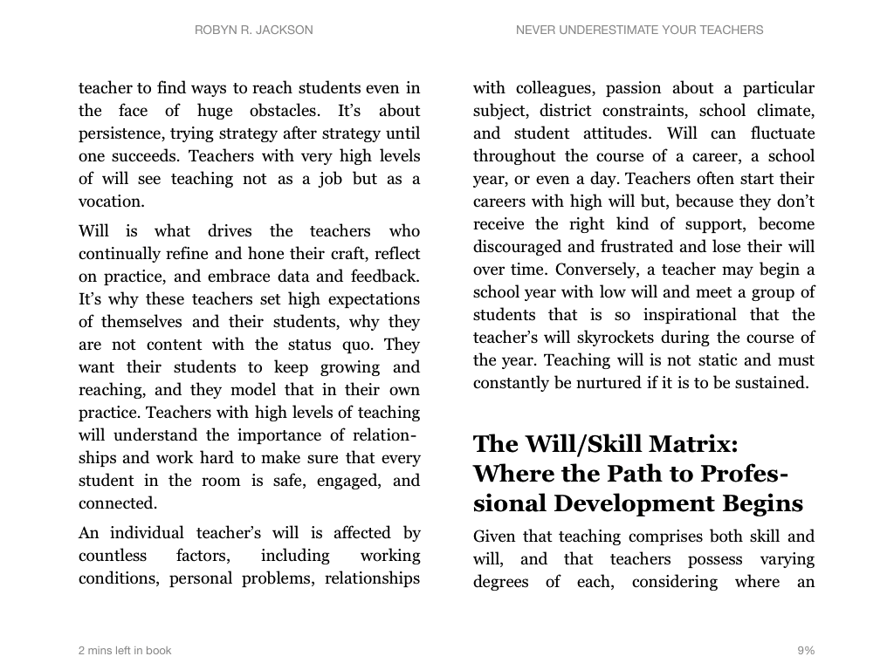
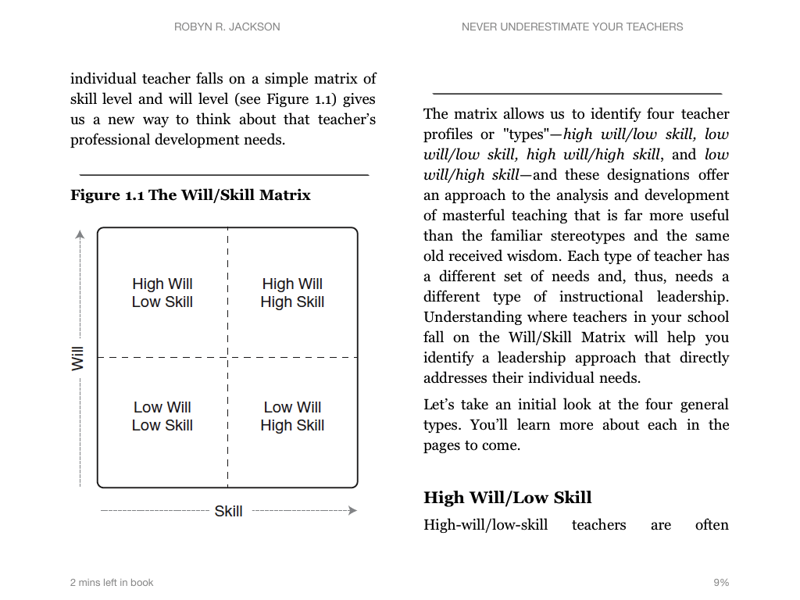

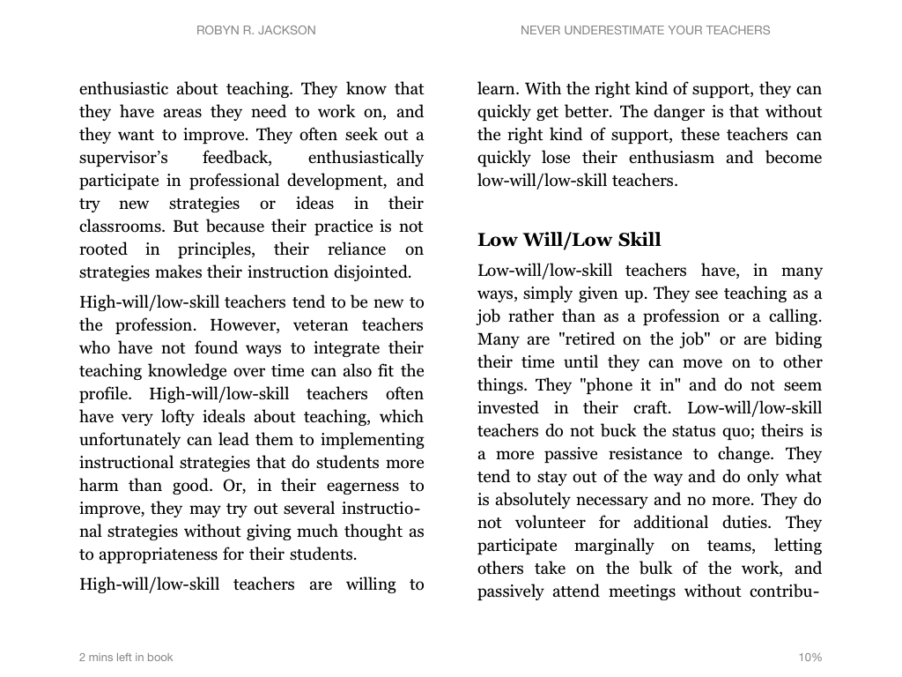

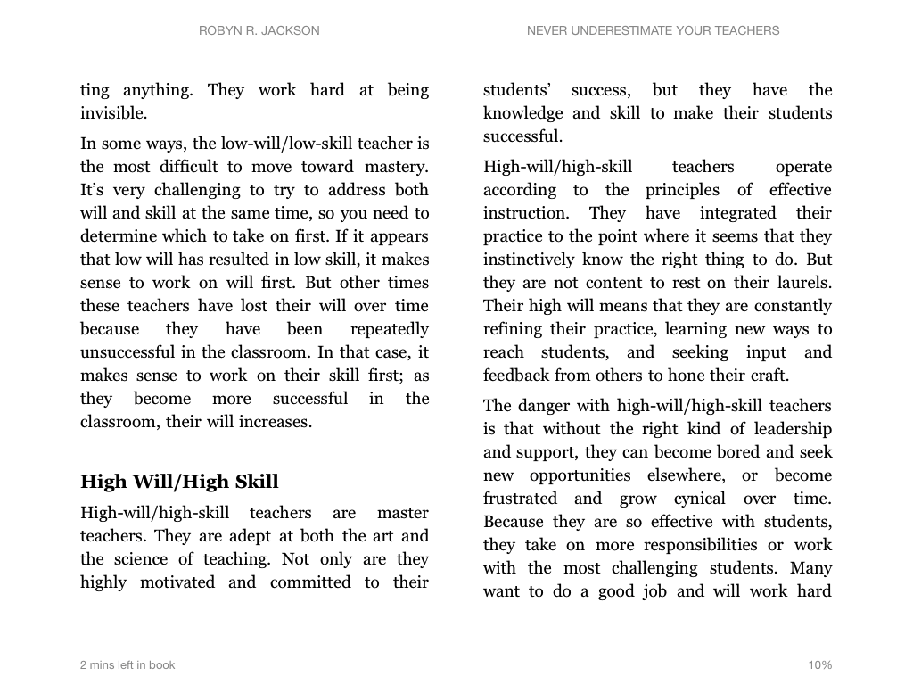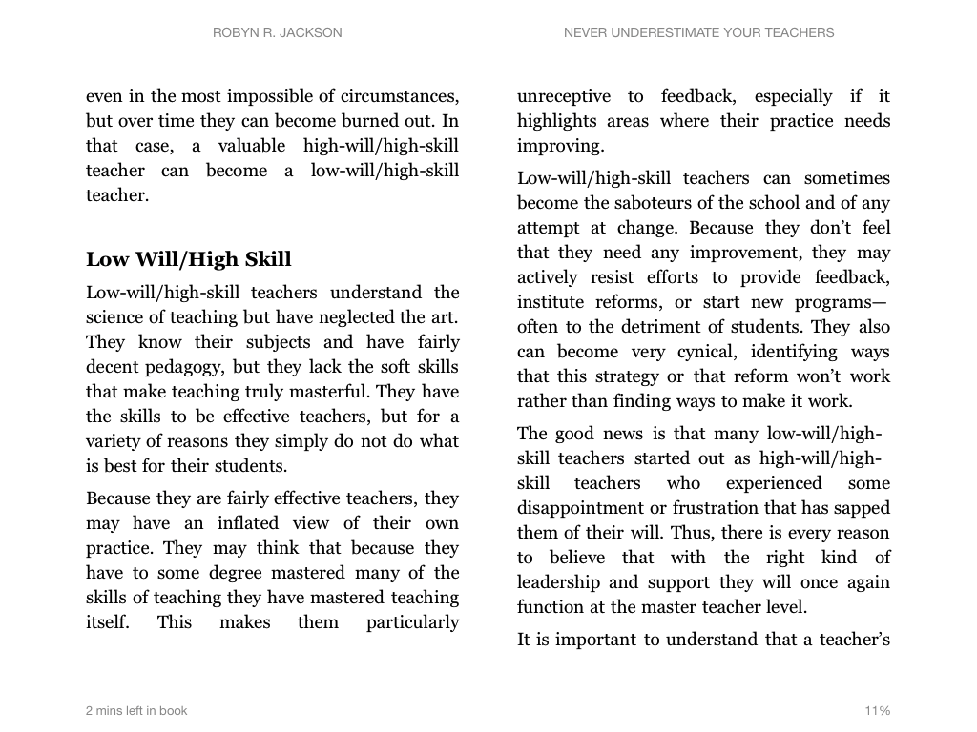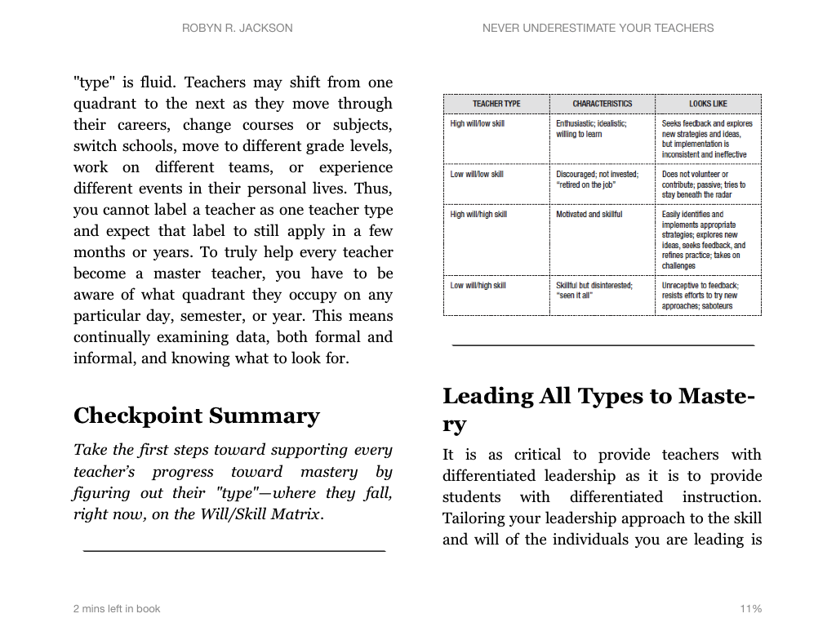

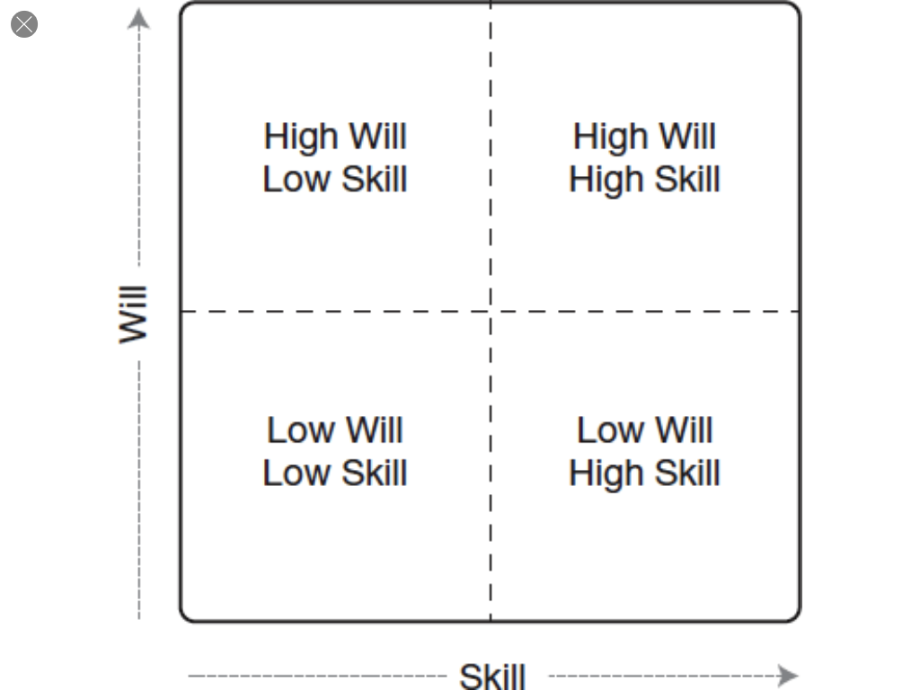

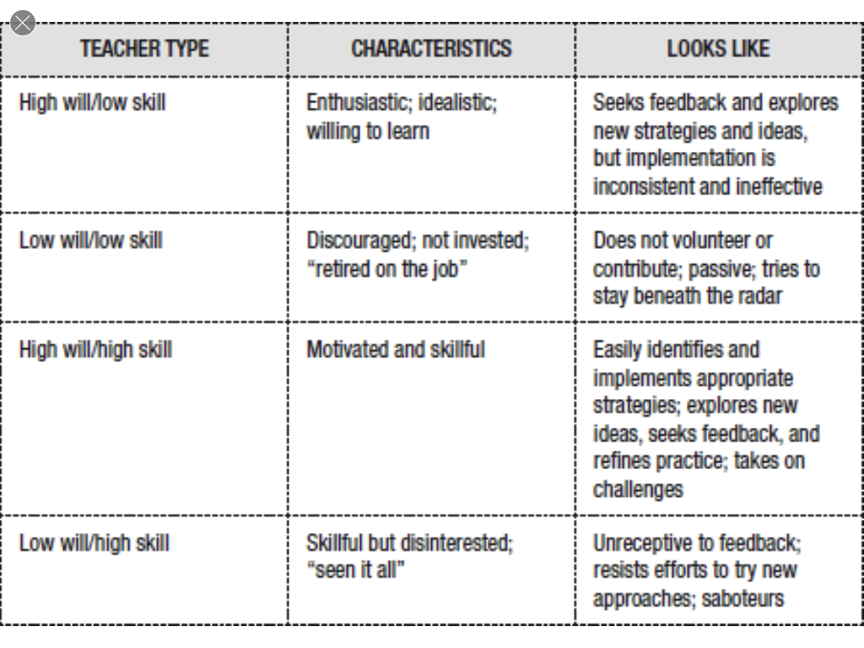

Activity: Take a moment and determine where most of your teachers fall on the Will/Skill Matrix. Discuss at your table how you might use this matrix to help improve teaching and learning. Record your responses below.

1.11 Building Trust
Building Trust
Adapted from Bloom (2005)

Trust is difficult to achieve. People must engage in consistent hard work to obtain it, for trust grows slowly. Because of the complex dynamics surrounding trust, it cannot be built in a short period of time and have lasting value. It takes time, physical presence, and human energy. However, as trust between people grows, behaviors change and interpersonal dynamics are transformed. As trust grows, the barriers that prevent candor and openness lessen. People become more expressive, impulsive, frank and spontaneous. Their communication is efficient and clear. They risk conflict and confrontation, opening doors to deeper communication, involvement, and commitment. – Chartier (1991)

According to Aguilar (2013), building trust is essential for a coach’s success. She claims that because so much hinges on a coach’s ability to gain and maintain trust, it is critical that a coach has a reflective practice.

What is building trust and why trust is significant in coaching? Building trust is on-going attention to professional and personal skills of sincerity, reliability, competence. Coaches must cultivate the ability to provide useful feedback that will fuel a teacher’s ongoing reflective practice. None of this is possible if the coach lacks basic affinity for trust and rapport with teachers.

Activity: Think of someone other than a family member or personal friend in whom you have a high degree of trust. List the characteristics of the individual that supported the establishment of trust. Share the list with a partner.

Characteristics of a Trusted Individual…

Concept Map for Building Trust
What you think it is...

What it is not…

Building Trust
Examples…
Definition…
Activity: Below are two different sets of steps to build trust. Read the information and determine which step/s you could strengthen. Write a short, personal goal to improve in that area.

What are the steps to building trust as a coach? (Bloom, 2005)
Demonstrate sincerity:
- Be fully present in the coaching relationship
- Demonstrate basic personal regard
- Be truthful
- Ask for permission
- Admit mistakes
- Maintain confidentiality

Demonstrate reliability:
- Clarify expectations
- Keep commitments
- Behave consistently
- Be available

Demonstrate competence:
- Let the teacher know about your expertise and experience
- Find outside expertise in cases where you don’t possess it
- Remember that your job is to be a competent coach, not a competent principal (Unless, of course, you are the principal.)
- Have high expectations of yourself and of the coaching process

Ten Steps to Building Trust (Aguilar, 2013)
- Plan and Prepare: The first meetings should be carefully planned. Pre-plan and anticipate possible questions. Determine the possible outcomes. Rehearse if possible.
- Cautiously Gather Background Information: Be careful about with whom you speak to gather impressions about a potential client. Go into the first meeting with positive feelings.
- Establish Confidentiality: Make sure the client is aware of exactly what will and won’t be communicated and how it will be communicated. Suggestion is to share the teacher, time, topics and tasks. Client must feel confident that you will not share information with his/her supervisor.
- Listen: Practice deep listening for the purpose of understanding where the client is coming from. Listen with acceptance.
- Ask Questions: Coaching questions can help shift a client’s perception and enhance their understanding. Clarifying questions can reveal their thinking.
- Connect: Make personal connections. This can help see your client as a person.
- Validate: Uncover the client’s assets and bring them to the forefront. Validation must be sincere. Help your client see their strengths.
- Be Open about Who You Are and What You Do: Share your vision and why you do what you do.
- Ask Permission to Coach: Asking permission often times help build trust. It is respectful.
- Keep Commitments: Fulfill the promises we make. Only commit to what you are willing and able to do. It is better to underpromise and overdeliver.

My personal improvement goal for building trust is to…

1.12 Building Rapport

Building Rapport

Being in rapport is the ability to enter someone else’s model of the world and let them know that we truly understand their model. – Brooks (1989)

What is building rapport? Rapport is a mutual understanding between individuals that they share each other’s concerns.

Why is building rapport important in coaching? In order for teachers to respect the coach and actually participate fully in the coaching conversation, the coach must establish at least a minimum of rapport with the teacher. Sharing a few common professional concerns helps communicate to the teacher that you understand their work environment – the context in which you are asking them to change practice.

How to Build Rapport | How to Build Rapport Coaching
Share personal and professional connections
Be fully present in the conversation
Be aware of your body language
Listen impeccably
Communicate acceptance

1.13 Listening
Listening

Listening is an art that when done well delivers tremendous benefits. The goal of listening well is to achieve win-win communication.

Listening is a skill, and like any skill it can be practiced and improved…But it also needs to be looked at another way, as an outgrowth of an attitude of caring and concern for other people…showing that you care, suspending your own interests, and making yourself available to others takes some effort. It means devoting alertness to another’s words.

Listening well is often silent but never passive. – Nichols (1995)

What is listening? Listening is an active activity that involves receiving, deciphering, and perceiving a message with intent to respond. Planning ahead for a conversation improves a coach's ability to listen to a message.

Why is listening important as a coach? Listening carefully to a teacher helps the coach determine where the teacher is in terms of the change process, the implementation of a new practice, and/or the attitude hindering the coaching.

5 Questions To Ask Yourself As You Listen

- What are the facts and details embedded in the speaker’s words?

- What do the speaker’s words convey?

- Are the spoken messages free of generalizations, bias, of blame and finger pointing?

- Is the speaker reasoned in the choice of words used to describe the event or person involved?

- Are there patterns of language or comments that tell us about the speaker’s way of thinking?

Activity: With a partner, read “Comments of a New Teacher” and analyze what the teacher is saying using the “5 Questions To Ask Yourself As You Listen.” Be ready to share your analysis with the whole group.

Comments of a New Teacher

I think things are going well so far. I do have a bunch of kids who will not pay attention, and are behavior problems, they’re just bad kids and don’t want to learn. The other teachers at my grade level agree with me, and they feel sorry that I have to deal with all of them in one classroom. I’ve tried calling the parents, but they are no help at all, so if the kids want to fail, then that’s their choice. Maybe when they get those bad grades, then they’ll start to shape up.

1 .

2.

3.

4.

5.

Activity: With a partner, decide who is A and who is B. Partner A speak and partner B listens. Partner A speak for two minutes reflecting on personal learning and insights from this workshop thus far. At the signal, stop talking.

Partner B uses the “5 Questions To Ask Yourself As You Listen,” as a reference and verbally reflects on the speakers comments.

Reverse roles for the second round.

1.14 Non-Verbal Communication

Nonverbal Communication

Only 7% of the emotional meaning of a message is communicated through the exchange of words. Some 38% is communicated by vocal intonation, and the remaining 55% is expressed through gestures, posture, facial expressions, and other physical cues. -- Bloom (2005)

When we speak (or listen), our attention is focused on words rather than body language. But our judgment includes both. An audience is simultaneously processing both verbal and nonverbal cues. Body movements are not usually positive or negative in and of themselves; rather, the situation and the message will determine the appraisal. -- Givens (2000)

I can never bring you to realize the importance of sleeves, the suggestiveness of thumbnails, or the great issues that may hang from a bootlace. -- Sherlock Holmes to Watson in "A Case of Identity"
He even walked like a crab, as if he were cringing all the time. -- Elia Kazan, commenting on actor James Dean (Dalton 1984:53)

What is nonverbal communication? Nonverbal communication is a broad term used to describe any method of transferring information without words and may include body language and facial cues, fashion and personal grooming, hand gestures, and graphical signs and design.

How is nonverbal communication important to coaching? Nonverbal cues may provide the coach with hints that a teacher is resistant or does not understand. Knowing a few clues about body language may cue the coach to check for understanding or probe for specificity. The coach should also be aware of his/her own body language in order to send physical messages that support the verbal coaching messages and the precepts of trust and rapport.

Tips: Information about reading body language can be greatly over-generalized. The point of studying body language in the context of coaching is to provide the coach with one, of many, interpersonal communication tools.

The best use of reading body language is for the coach to check for understanding. For example, if a person leans back and folds their arms it may signal the person is resistant to the coaching message. The coach might say in response, “How might I further clarify what we’re talking about?” Or, the reclining and folding of arms may simply mean the teacher’s back aches. Either way, the coach might probe the nonverbal clue by checking for clarity (“How might I further clarify what we’re talking about?”) and then simply move on with the conversation.

In general, the coaches’ own body language should be open and forward. See details about this below.

Open Closed Forward Back

OPEN and CLOSED gestures are the most obvious. People with arms folded and legs crossed and bodies turned away are often signaling they are rejecting messages. People showing open hands, fully facing you and both feet planted on the ground are most likely accepting them.

Acceptance -- open body language -- might be indicated by: standing erect, sitting with legs apart, open palm, raised eyebrows, smiling, arms uncrossed, nodding, eye contact.

Rejection -- closed body language -- might be indicated by: hands clenched, frown, head down, legs crossed, sitting or moving back, slumped posture, doodling, finger or foot tapping, arms crossed.

FORWARD and BACK gestures indicate whether people are actively or passively reacting to communication. When a person is leaning forward and pointing towards you it is a strong indication s/he is actively accepting or rejecting the message. When they are leaning back, looking up at the ceiling, doodling on a pad, cleaning their glasses they may be either passively absorbing or ignoring it.

Acceptance -- forward body language -- might be indicated by: leaning forward, head tilted, sitting up, extended arm or hand.

Rejection -- back body language -- might be indicated by: slumped posture, hands on hips, leaning or moving away.

Activity: With a partner, review the photos below and indicate if the body language is Open, Closed, Forward, and/or Back. The first two are done for you.

 | Open  Closed  Forward  Back | 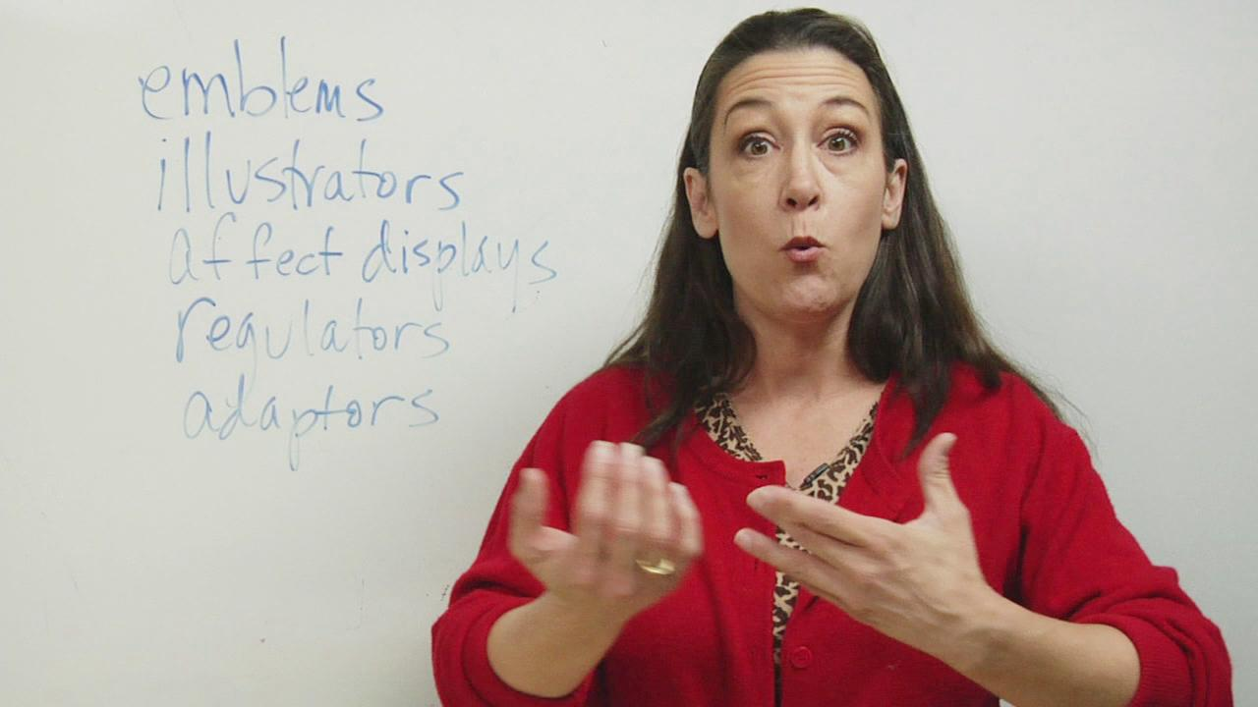 | Open  Closed  Forward  Back
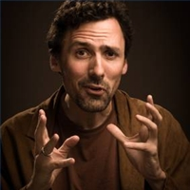 | Open  Closed  Forward  Back |  | Open  Closed  Forward  Back
 | Open  Closed  Forward  Back |  | Open  Closed  Forward  Back

 | Open  Closed  Forward  Back |  | Open  Closed  Forward  Back
 | Open  Closed  Forward  Back |  | Open  Closed  Forward  Back

PART 2: Coaching Planning, Practicing and Formats

Objectives:

2.0 Participants will explain in one sentence the contents of today’s workshop.

2.1 Participants will draw non-linguistic representations and explain in writing various methods for collecting the data.

2.2 Participants will write an analysis of the data.

2.3 Participants will write an objective for a coaching conference.

2.4 Participants will write an outline planning the conference.

2.5 Participants will write a summary of the theories behind differentiated coaching messages.

2.6 Participants will conduct a coaching conference.

2.7 Participants will explain in writing key concepts of various coaching formats and determine which format is most applicable for given settings.

