STEM Lesson Planning

STEM lesson characteristics:
- Integration of knowledge and skills from Science, Technology, Engineering and Mathematics.
- Science
  - Grade Level science Standards from Hawai`i Content and Performance Standards III
  - Science Inquiry Activities (pgs.2 and 3)

- Technology
  - Student use a variety of technology in real world applications.
Measuring technology: rulers, timers, thermometers, pedometer, speedometer
Communication Technology: internet reach, writing on a blog or web page, Excel data table/graph, typed research/lab report, photo/video documentation
Applied Technology: create a computer program or app, build and program a robot, design and build a solar car/wind turbine/solar water heater

- Engineering
  - Engineering Design Activities (pg.4)

- Math
  - Grade Level Math Common Core Standards
  - Common Core Math Practices

- Inquiry/problem based lessons.
- Extended, student-led activities focused upon authentic questions or problems in the student’s school, community or world. (pg.5 and 6)

- 5 E Model (pg.7-9)

- Students use higher order thinking skills (DOK), creative thinking and collaboration. (pg.10-12)
Examples: field trip, lab activities, collecting data from classmates or community, designing a solution to a school or community issue

- Integrates with Common Core Reading and Writing Standards.

Science Inquiry Activities

“Scientific inquiry reflects how scientists come to understand the natural world, and it is at the heart of how students learn. From a very early age, children interact with their environment, ask questions, and seek ways to answer those questions. Understanding science content is significantly enhanced when ideas are anchored to inquiry experiences.

Scientific inquiry is a powerful way of understanding science content. Students learn how to ask questions and use evidence to answer them. In the process of learning the strategies of scientific inquiry, students learn to conduct an investigation and collect evidence from a variety of sources, develop an explanation from the data, and communicate and defend their conclusions.”

NSTA Position Statement on Scientific Inquiry. http://www.nsta.org/about/positions/inquiry.aspx

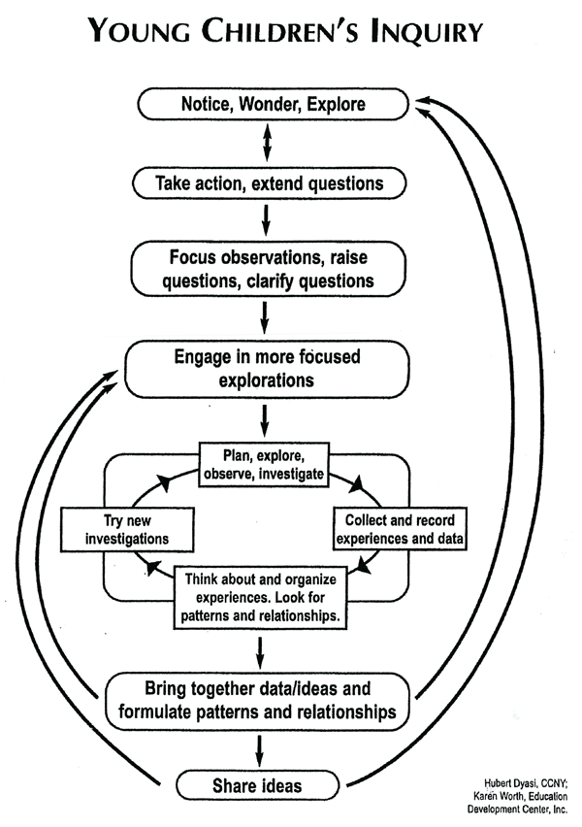
Science Inquiry Activities Matrix

The different features of an inquiry activity can be more teacher led or student led depending on the topic, student skills and teacher needs.

Essential Features of Classroom Inquiry and Their Variations

Essential Feature | Variations
1. Learner engages in scientifically oriented questions | Learner poses a question | Learner selects among questions, poses new questions | Learner sharpens or clarifies question provided by teacher, materials, or other  source | Learner engages in question provided by teacher, materials, or other source
2. Learner gives priority to evidence in responding to questions | Learner determines what constitutes evidence and collects it | Learner directed to collect certain data | Learner given data and asked to analyze | Learner given data and told how to analyze
3. Learner formulates explanations from evidence | Learner formulates  explanation after  summarizing evidence | Learner guided in process of formulating explanations from evidence | Learner given possible ways to use evidence to formulate explanation | Learner provided with evidence
4. Learner connects explanations to scientific knowledge | Learner independently  examines other resources and forms the links to explanations | Learner directed toward areas and sources of scientific knowledge | Learner given  possible connections
5. Learner communicates and justifies explanations | Learner forms reasonable and logical argument to communicate explanations | Learner coached in development of communication | Learner provided broad guidelines to use to sharpen communication | Learner given steps and procedures for communication
More ---------------------- Amount of Learner Self-Direction -------------------------- Less
Less --------------- Amount of Direction from Teacher or Material ----------------- More

from Inquiry and the National Science Education Standards: A Guide for Teaching and Learning. NRC, National Academy Press: Washington, DC, 2000.

Engineering Design Process

1. State the Problem:
The teacher will explain the problem and the guidelines. The teacher and students determine the goals or desired results. Students should state the challenge problem in their own words. Example: How can I design a __________ that will __________?
2. Generate Ideas:
Each student in the group should sketch his or her own idea. Labels and arrows should be included to identify parts and how they might move. These drawings should be quick and brief.
They can then discuss ideas with the group and add new ideas or combine ideas. Students may need to read books or search on the internet to lean more about the problem or generate additional ideas.

3. Select a Solution:
Students should work in teams and identify the design that appears to solve the problem the best. Students should write a statement that describes why they chose the solution. This should include some reference to the criteria and constraints identified above.
4. Build the Item:
Students will construct a full-size or scale model based on their drawings. The teacher will help identify and acquire appropriate modeling materials and tools.
5. Evaluate:
Students will test out their prototype and determine if it met the goals and desired results. If the desired goals are not met, the students identify changes that need to be made and propose a new solution.
6. Present Results:
Students present final model to the class. Orally or in writing, they explain how it works, how it addressed the challenge and any further modifications that would improve the design.

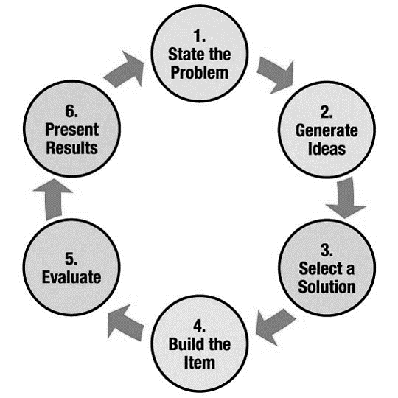

http://www.nasa.gov/audience/foreducators/plantgrowth/reference/Eng_Design_K4.html#.U0XArvldWSo
Project Based Lessons

Each project based lessons includes two levels of inquiry; one that provides some structure and direction for students, and a second that allows students more opportunity to operate independently. The goal is to gradually increase students’ independent questioning, planning and data/information analysis skills.
Not all knowledge can be derived from the performance of a hands-on task. Therefore, each curriculum-embedded task gives students opportunities to expand their understanding of concepts through reading, writing, speaking and listening components. These elements foster student collaboration, classroom discourse, and the establishment of a learning community.

How to Design a Project Based Lesson
1. Identify the final understanding that you wish students to have.
- i. e. what is the really important thing that they need to know for future success?
- or, what is the fundamental Big Idea that the Standards indicate is important?

2. Identify the basic facts (i. e. observations, measurements, data, etc) that lead us to infer that this final understanding may actually be true. There may be a number of examples that will work equally well

3. Develop a lead-in scenario, or "hook" that will get your students engaged in thinking about this issue.
- the "hook" will vary, depending on your particular group of students (rural, urban, geographical location, etc)
- usually, a "hook" works best if it relates the science to students' out-of-school lives. Students of all ages (including adults) put more effort into learning things that they perceive as relevant.
- Sometimes, wholly fantastic scenarios have also been used successfully to engage students--such as introducing geometry by asking students to think of themselves as living in Flatland, a 2-dimensional world where one's shape determines how one can move. Students' increasing familiarity with video games may make this approach effective for some students.

4. Follow the lead-in with an activity in which students acquire the basic facts of the example you have chosen, as they work through the scenario. Depending on the example, students may acquire these facts by:
- performing an experiment or investigation. The observations or measurements from this experiment are the data (i. e. basic facts) that students will need.
- searching books or online resources.
- the teacher giving them the data at appropriate points during the scenario. This is currently a commonly-used method--for example, simulating a fossil excavation, with students extracting "fossils" from an envelope containing paper representations or cut-outs of the specimens.

5. Give students time to wrestle with the basic facts, preferably in small groups.
- At each step, their task must be very clear and discrete--e. g. to answer a specific question, or to decide between two choices, etc. It is important to avoid vague instructions, which will likely lead to non-productive activity.
- With appropriate guidance, students should be able to develop their own interpretations of the data.
- By discussing these issues in small groups, students who may be reluctant to "say the wrong thing" in front of the entire class will be more likely to participate actively in the discussion.

6. Open up the discussion to include the entire class, comparing what different student groups have proposed.
- This discussion should focus on how the data--the basic facts--lead us to the explanations that we propose.
- One should strive toward an atmosphere in which the discussion is about the data, not about students' opinions. In this discussion, there are no dumb questions. There are no wrong answers. [There also are no "right" answers, in terms of being absolutely true; scientific knowledge is the interpretation of data, not a process of matching data to some previously-known truth. ]
- To the extent that the overall lesson plan may be aimed at specific content knowledge identified in the Standards, it may be important to summarize the discussion by stating current scientific understanding. We would hope that the example chosen for the lesson, the specific data, and the teacher's guidance as students wrestle with the data, will lead students fairly close to this current scientific understanding. At least, it should lead students close enough to understand what the teacher's final summary means. Perhaps more importantly, it should help students understand where current scientific understanding comes from.

The 5E Model of the Learning Cycle

A useful structure for inquiry-based learning units follows a LEARNING CYCLE model. One such model, the “5-E Model”, engages students in experiences that allow them to observe, question and make tentative explanations before formal instruction and terminology is introduced.

Phase 1: ENGAGE
During this segment the teacher sets the stage for learning by getting the students’ attention and focus. The students are exposed to a short event or activity that is related to the concept and hooks their curiosity. It may also provide an opportunity for the teacher to activate learning, assess prior knowledge, and have students share prior experiences about the general topic. The concept is NOT taught during this phase.
- Use a short activity, demonstration, discrepant event, trade book, or other event to “hook” the learners. When implementing guided inquiry, this segment should take about 5-7 minutes—short and sweet! If the students are expected to formulate their own inquiry questions (open inquiry), this phase takes much longer; they must first make observations that lead to questions.
- In guided inquiry, the teacher poses the inquiry question at the end of this phase. In open inquiry, the students should have formulated their inquiry question by the end of this phase.

Phase 2: EXPLORE
During this segment, students are engaged in inquiry in response to the question. They are encouraged to make predictions or develop and test a hypothesis without direct instruction from the teacher. They collect evidence and data, record and organize information, share observations, and work in cooperative groups. This stage also provides opportunities for students with diverse experiences to share their different understandings and broaden the perspectives of the entire class. During this phase, the teacher serves as a facilitator, guiding students’ thinking with questions.
Students explore the concept using the inquiry question without being told what the actual concept is ahead of time. This is the beginning of their own construction of the concept without being predisposed by the teacher. In other words, the teacher should NOT “tell” the students the concept.
- When implementing guided inquiry, include an advance organizer (particularly for younger children) to support students’ ability to record their data. When implementing open inquiry (or guided inquiry with older students), support may be needed to help students record the data they choose to collect.

Phase 3: EXPLAIN
During this teacher-directed stage, the class comes together to discuss what was discovered and learned from the investigation. First, the students share what they learned from their exploration while the teacher facilitates data-processing techniques from the information collected during the exploration. As the information is discussed, the teacher typically explains the scientific concepts associated with the investigation, introducing vocabulary—providing a common language for the class to use. This helps students to articulate their thinking and describe their experiences in scientific terms. The teacher can then continue to introduce details using direct instruction or lecture, audiovisual resources, on-line sources, or computer software programs.
This phase is sometimes called the concept development stage because newly developed concepts are assimilated into the cognitive structure of the students. In other words, you help the students construct the lesson’s concept. This is sometimes referred to as the “teaching” part of the lesson.
- The first event in this segment is students sharing their findings from the Explore segment. They must justify answers by using the data they have collected.
- Re-teach any concept areas that lack clarity for the students, or address any misconceptions.
- Closure—At the end of the above discussion, revisit the concept, reinforcing what the students learned from the exploration.

Phase 4: EXTEND/ELABORATE
During this phase, the teacher provides activities that reinforce the concept. This can be accomplished by applying the evidence to new or real-world situations or through further investigation and/or research.
During this segment students are expected to expand upon their newly acquired knowledge by applying it in a somewhat different context using a NEW activity. The focus here is often on application: What will you have them do to apply their knowledge to a new and/or real-world situation? DO NOT INTRODUCE A NEW CONCEPT – MERELY ELABORATE ON THE CONCEPT TAUGHT DURING THE EARLIER PHASES OF THE LESSON.
- State the instructions and procedure for the activity.
- Closure—bring this segment to a close by revisiting the lesson concept and posing questions to the students that elicit connections between this activity and the lesson concept.

Phase 5: EVALUATE
This phase includes two parts—
- List and explain the formative assessment strategies that will be embedded throughout the lesson.
- List and explain the summative assessment(s) you will use to grade student performance

The 5E Model of Instruction

5E Definition | Teacher Behavior | Student Behavior
Engage
• Generate interest  • Access prior knowledge  • Connect to past knowledge  • Set parameters of the focus  • Frame the idea | • Motivates  • Creates interest  • Taps into what students know or think about the topic  • Raises questions and encourages responses | • Attentive in listening  • Ask questions  • Demonstrates interest in the lesson  • Responds to questions demonstrating their own entry point of understanding
Explore
• Experience key concepts  • Discover new skills  • Probe, inquire, and question experiences  • Examine their thinking  • Establish relationships and understanding | • Acts as a facilitator  • Observes and listens to students as they interact  • Asks good inquiry-oriented questions  • Provides time for students to think and to reflect  • Encourages cooperative learning | • Conducts activities, predicts, and forms hypotheses or makes generalizations  • Becomes a good listener  • Shares ideas and suspends judgment  • Records observations and/or generalizations  • Discusses tentative alternatives
Explain
• Connect prior knowledge and background to new discoveries  • Communicate new understandings  • Connect informal language to formal language | • Encourages students to explain their observations and findings in their own words  • Provides definitions, new words, and explanations  • Listens and builds upon discussion form students  • Asks for clarification and justification  • Accepts all reasonable responses | • Explains, listens, defines, and questions  • Uses previous observations and findings  • Provides reasonable responses to questions  • Interacts in a positive, supportive manner
Extend/Elaborate
• Apply new learning to a new or similar situation  • Extend and explain concept being explored  • Communicate new understanding with formal language | • Uses previously learned information as a vehicle to enhance additional learning  • Encourages students to apply or extend the new concepts and skills  • Encourages students to use terms and definitions previously acquired | • Applies new terms and definitions  • Uses previous information to probe, ask questions, and make reasonable judgments  • Provides reasonable conclusions and solutions  • Records observations, explanations, and solutions
Evaluate
• Assess understanding (Self, peer and teacher evaluation)  • Demonstrate understanding of new concept by observation or open-ended response  • Apply within problem situation  • Show evidence of accomplishment | • Observes student behaviors as they explore and apply new concepts and skills  • Assesses students’ knowledge and skills  • Encourages students to assess their own learning  • Asks open-ended questions | • Demonstrates an understanding or knowledge of concepts and skills  • Evaluates his/her own progress  • Answers open-ended questions  • Provides reasonable responses and explanations to events or phenomena

Based on the 5E Instructional Model presented by Dr. Jim Barufaldi at the Eisenhower Science Collaborative Conference in Austin, Texas, July 2002.
DOK

Depth of Knowledge is reference to the complexity of metal processing that must occur to answer a question, perform a task, or generate a product. It is not determined by the verb describing the action, but by the context in which the verb is used and the depth of thinking required. In classroom analysis, look for alignment in the depth of thinking

Level 1 Recall and Reproduction requires recall of information, such as a fact, definition, term, or a simple procedure, as well as performing a simple science process or procedure. Level 1 only requires students to demonstrate a rote response, use a well-known formula, follow a set procedure (like a recipe), or perform a clearly defined series of steps. A “simple” procedure is well-defined and typically involves only one-step. Verbs such as “identify,” “recall,” “recognize,” “use,” “calculate,” and “measure” generally represent cognitive work at the recall and reproduction level. Simple word problems that can be directly translated into and solved by a formula are considered Level 1. Verbs such as “describe” and “explain” could be classified at different DOK levels, depending on the complexity of what is to be described and explained.
A student answering a Level 1 item either knows the answer or does not: that is, the answer does not need to be “figured out” or “solved.” In other words, if the knowledge necessary to answer an item automatically provides the answer to the item, then the item is at Level 1. If the knowledge necessary to answer the item does not automatically provide the answer, the item is at least at Level 2.

Level 2 Skills and Concepts includes the engagement of some mental processing beyond recalling or reproducing a response. The content knowledge or process involved is more complex than in level 1. Items require students to make some decisions as to how to approach the question or problem. Keywords that generally distinguish a Level 2 item include “classify,” “organize,” ”estimate,” “make observations,” “collect and display data,” and “compare data.” These actions imply more than one step. For example, to compare data requires first identifying characteristics of the objects or phenomenon and then grouping or ordering the objects. Level 2 activities include making observations and collecting data; classifying, organizing, and comparing data; and organizing and displaying data in tables, graphs, and charts.
Some action verbs, such as “explain,” “describe,” or “interpret,” could be classified at different DOK levels, depending on the complexity of the action. For example, interpreting information from a simple graph, requiring reading information from the graph, is a Level 2. An item that requires interpretation from a complex graph, such as making decisions regarding features of the graph that need to be considered and how information from the graph can be aggregated, is at Level 3.

Level 3 Strategic Thinking requires deep knowledge using reasoning, planning, using evidence, and a higher level of thinking than the previous two levels. The cognitive demands at Level 3 are complex and abstract. The complexity does not result only from the fact that there could be multiple answers, a possibility for both Levels 1 and 2, but because the multi-step task requires more demanding reasoning. In most instances, requiring students to explain their thinking is at Level 3; requiring a very simple explanation or a word or two should be at Level 2. An activity that has more than one possible answer and requires students to justify the response they give would most likely be a Level 3. Experimental designs in Level 3 typically involve more than one dependent variable. Other Level 3 activities include drawing conclusions from observations; citing evidence and developing a logical argument for concepts; explaining phenomena in terms of concepts; and using concepts to solve non-routine problems.

Level 4 Extended Thinking requires high cognitive demand and is very complex. Students are required to make several connections—relate ideas within the content area or among content areas—and have to select or devise one approach among many alternatives on how the situation can be solved. Many on-demand assessment instruments will not include any assessment activities that could be classified as Level 4. However, standards, goals, and objectives can be stated in such a way as to expect students to perform extended thinking. “Develop generalizations of the results obtained and the strategies used and apply them to new problem situations,” is an example of a Grade 8 objective that is a Level 4. Many, but not all, performance assessments and open-ended assessment activities requiring significant thought will be at a Level 4.
Level 4 requires complex reasoning, experimental design and planning, and probably will require an extended period of time either for the science investigation required by an objective, or for carrying out the multiple steps of an assessment item. However, the extended time period is not a distinguishing factor if the required work is only repetitive and does not require applying significant conceptual understanding and higher-order thinking. For example, if a student has to take the water temperature from a river each day for a month and then construct a graph, this would be classified as a Level 2 activity. However, if the student conducts a river study that requires taking into consideration a number of variables, this would be a Level 4.
WestEd Comprehensive School Assistance Program March, 2014

Hess’ Cognitive Rigor Matrix & Curricular Examples: Math/Science
Applying Webb’s Depth-of-Knowledge Levels to Bloom’s Cognitive Process Dimensions
Revised Bloom’s  Taxonomy | Webb’s DOK Level 1  Recall & Reproduction | Webb’s DOK Level 2  Skills & Concepts | Webb’s DOK Level 3  Strategic Thinking/ Reasoning | Webb’s DOK Level 4  Extended Thinking
Remember  Retrieve knowledge from long-term memory, recognize, recall, locate, identify | - Recall, observe, & recognize facts, principles, properties  - Recall/ identify conversions among representations or numbers (e.g., customary and metric measures)
Understand  Construct meaning, clarify, paraphrase, represent, translate, illustrate, give examples, classify, categorize, summarize, generalize, infer a logical conclusion (such as from examples given), predict, compare/contrast, match like ideas, explain, construct models | - Evaluate an expression  - Locate points on a grid or number on number line  - Solve a one-step problem o Represent math relationships in words, pictures, or symbols  - Read, write, compare decimals in scientific notation | - Specify and explain relationships (e.g., non-examples/examples; cause-effect)  - Make and record observations  - Explain steps followed  - Summarize results or concepts  - Make basic inferences or logical predictions from data/ observations  - Use models /diagrams to represent or explain mathematical concepts  - Make and explain estimates | - Use concepts to solve non-routine problems  - Explain, generalize, or connect ideas using supporting evidence  - Make and justify conjectures  - Explain thinking when more than one response is possible  - Explain phenomena in terms of concepts | - Relate mathematical or scientific concepts to other content areas, other domains, or other concepts  - Develop generalizations of the results obtained and the strategies used (from investigation or readings) and apply them to new problem situations
Apply  Carry out or use a procedure in a given situation; carry out (apply to a familiar task), or use (apply) to an unfamiliar task | - Follow simple procedures (recipe-type directions)  - Calculate, measure, apply a rule (e.g., rounding)  - Apply algorithm or formula (e.g., area, perimeter)  - Solve linear equations  - Make conversions among representations or numbers, or within and between customary and metric measures | - Select a procedure according to criteria and perform it  - Solve routine problem applying multiple concepts or decision points  - Retrieve information from a table, graph, or figure and use it solve a problem requiring multiple steps  - Translate between tables, graphs, words, and symbolic notations (e.g., graph data from a table)  - Construct models given criteria | - Design investigation for a specific purpose or research question  - Conduct a designed investigation  - Use concepts to solve non-routine problems  - Use & show reasoning, planning, and evidence  - Translate between problem & symbolic notation when not a direct translation | - Select or devise approach among many alternatives to solve a problem  - Conduct a project that specifies a problem, identifies solution paths, solves the problem, and reports results
Analyze  Break into constituent parts, determine how parts relate, differentiate between relevant-irrelevant,  distinguish, focus, select, organize, outline, find  coherence, deconstruct | - Retrieve information from a table or graph to answer a question  - Identify whether specific information is contained in graphic representations (e.g., table, graph, T-chart, diagram)  - Identify a pattern/trend | - Categorize, classify materials, data, figures based on characteristics  - Organize or order data  - Compare/ contrast figures or data  - Select appropriate graph and organize & display data  - Interpret data from a simple graph  - Extend a pattern | - Compare information within or across data sets or texts  - Analyze and draw conclusions from data, citing evidence  - Generalize a pattern  - Interpret data from complex graph  - Analyze similarities/differences between procedures or solutions | - Analyze multiple sources of evidence  - Analyze complex/abstract themes  - Gather, analyze, and evaluate information
Evaluate  Make judgments based on criteria, check, detect inconsistencies or fallacies, judge, critique |  |  | - Cite evidence and develop a logical argument for concepts or solutions  - Describe, compare, and contrast solution methods  - Verify reasonableness of results | - Gather, analyze, & evaluate information to draw conclusions  - Apply understanding in a novel way, provide argument or justification for the application
Create  Reorganize elements into new patterns/structures, generate, hypothesize, design, plan, construct, produce | - Brainstorm ideas, concepts, or perspectives related to a topic | - Generate conjectures or hypotheses based on observations or prior knowledge and experience | - Synthesize information within one data set, source, or text  - Formulate an original problem given a situation  - Develop a scientific/ mathematical model for a complex situation | - Synthesize information across multiple sources or texts  - Design a mathematical model to inform and solve a practical or abstract situation
© 2009 Karin Hess permission to reproduce is given when authorship is fully cited khess@nciea.org

