Tripod Survey: Tips and Reminders

Reminders:

The Shipping Deadline via FedEx is March 21 (not just the last date for survey administration)

Have a contingency plan (another administration date).

Blue or black ink pen is required for completing the surveys.
- The Tripod Student Survey is conducted in the same manner and culture as an assessment
- Disruption or conversations are not allowed during the survey
- The survey is untimed

For survey materials related questions (inaccuracies like missing surveys, delays etc.),

Contact Cambridge at Toll free number: 1-855-287-4763 (855-2-TRIPOD)
E-mail: tripodhelp@camb-ed-us.com

For survey administration related questions, contact HELP DESK at 586-4072 (Mon-Fri, 7:30 am -3:30 pm (HST) and/or your EES EO (Donna Lindsey, 239-3115)

- In case of any breach, SBTs will contact the complex area EES EO (Donna Lindsey)

- Students taking HSA-Alt and students with declination letter (box must be checked and the letter signed) DON’T take this survey. Keep declination letters on file.

- Absent students don’t need to make up the survey. However, teachers need administer TRIPOD to at least 5 students during each administration.

- Surveys (even extra blank ones) are coded/linked to a specific teacher. Blank surveys CAN NOT be swapped for a student in another teacher’s class.

- Make sure teachers are aware of survey directions, script and protocols. Preview resources for these under Implementation Staff tab on http://eesadmin.weebly.com

- Collect all materials (including blank ones), individually sealed envelopes, make a class packet, bundle all and ship together back to Cambridge.

- ONLINE Survey Materials, send back to SAO.

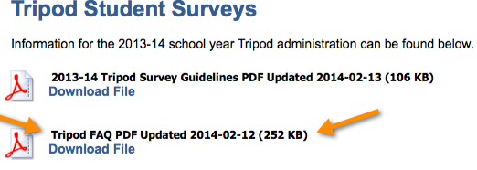
A. Prior to Administration:

A.1. Resources: Recently Update FAQs : Weebly Implementation Staff>>Implementation Support>>Tripod Student Surveys

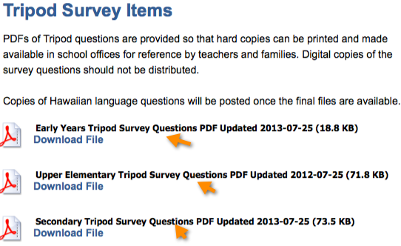
A copy of the Tripod Survey Questions should be available to teachers and parents in school office as a Reference. Print from Weebly website: Implementation Staff>>Implementation Support>>Tripod Student Surveys>> Survey Items

A.2. Classroom Tips:
For Younger students:
Prior to the administration date, they can practice using the pens and marking bubbles (bubbles need to be ‘marked’. Doesn’t necessarily mean the bubble has to be filled in completely).

Lower Elementary Survey
For students in grades K-2, students will be surveyed in small groups (5-10 at a time). The survey and each response option should be read aloud by a proctor, and NOT the teacher of record.

All students:
- Can X-out mistakenly marked bubble and mark again the bubble of choice (see below).
- Teachers can help students learn examples of questions where negative answer (no or disagreement) may actually be a favorable response for the teacher. See examples with black arrows below.

Lower Elementary Example
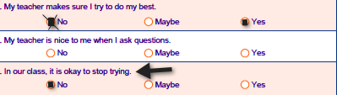
Upper Elementary Example 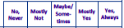
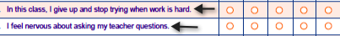

Secondary Example
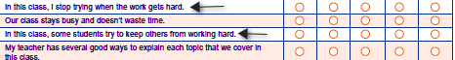

If the surveys have student name labels, there are additional “blank” surveys (with no names included) provided for any students added to the class since the roster was gathered.

B. During Administration:

- Before starting to take the survey, students must be REMINDED who they are taking the survey for and which class as necessary (math or science for example). They shouldn’t be under any wrong impression that the survey is for someone else than their regular teacher. This is especially important if they have a long term sub and also for younger students.

- Student teachers may support the classroom by proctoring that teacher’s class as well as reminding the students that they are completing the survey for their regular classroom teacher.

Monitoring and Assisting
- While students are taking the survey, it is important that students are able to complete the survey free of any coaching or pressure to respond in certain ways.

- While the survey is being administered, you may receive questions from students. You should answer only simple, clarifying questions or repeat the item. You should not explain any survey items for students. For example, proctors may define unknown words. Survey items should never be interpreted for students.

Important: If a student does not understand an item, or does not feel comfortable answering the item, they should not answer it – they should leave it blank.

